**IY5609 Digital Forensics**

Steganography & embedded devices NOT EXAMINABL

**Criminal Law** (passed by gov, punish wrongdoing)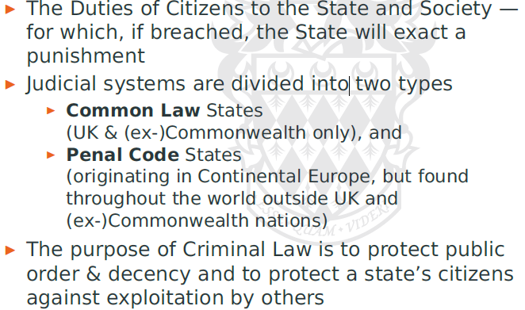

Many crimes = civil wrong + crime  
prosecuted criminally + subject of civil law  
crime OR civil wrong = which Court process   
(considerations = policing resources, capacity limitations, public interest)

**Civil Law** (adjudicated by Courts, disputes btwn indiv rectify a wrong, honour agreement, settle disputes) 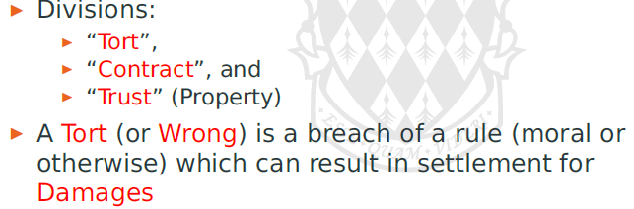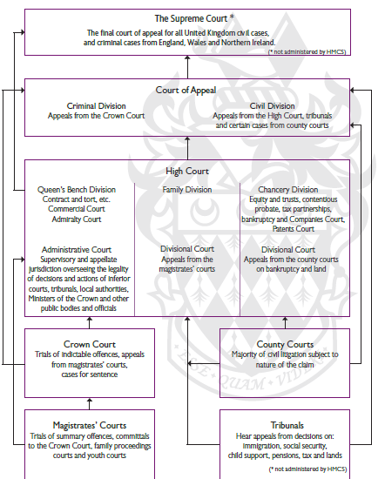

**Standards** of evidence = different (disclosure req)

Who can investigate?  
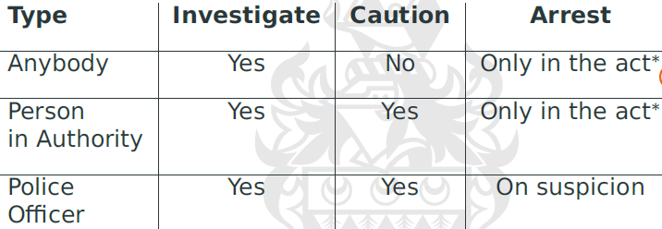

Caution = warn someone (no legal power)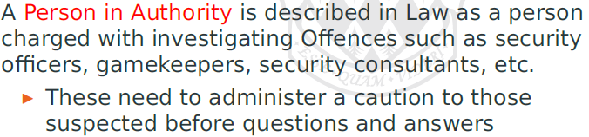

Procedural flaws = evidence inadmissible, compromise investigation

Investigators may: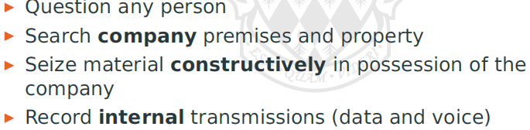

NEED for forensics evidence

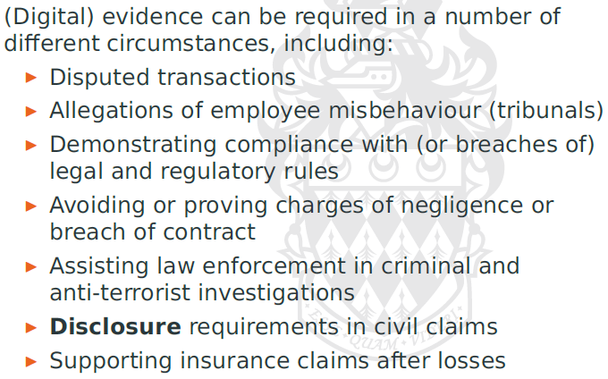

Digital Forensics (started in 1960s)

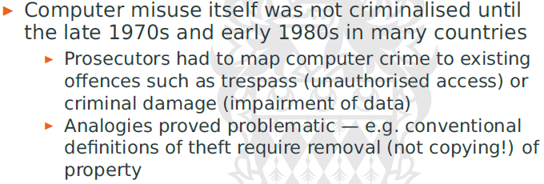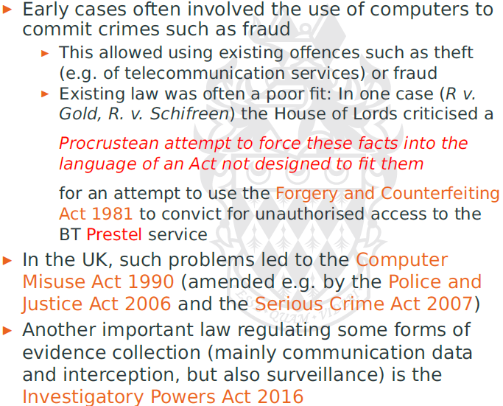

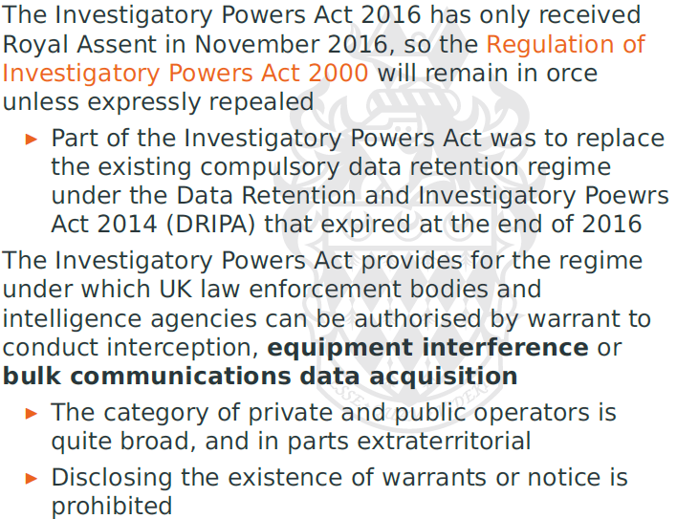

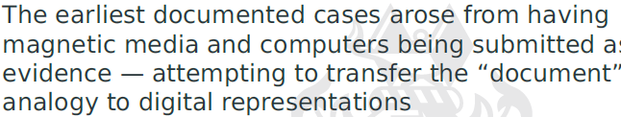

Computer/networks transcend internationally

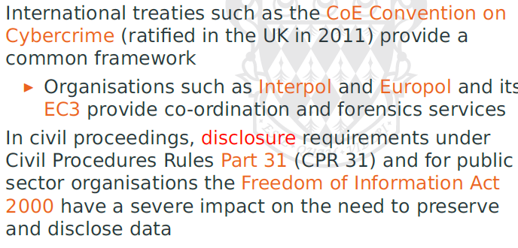

EVIDENCE

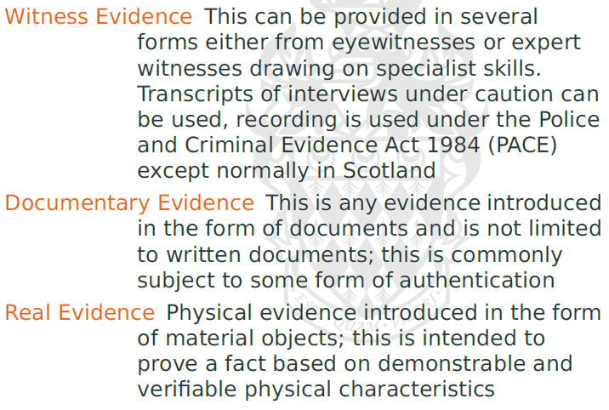

**Daubert Test:**  
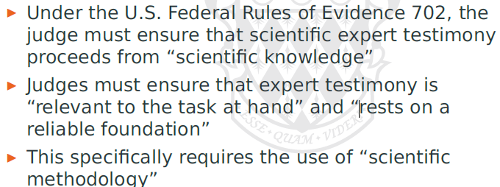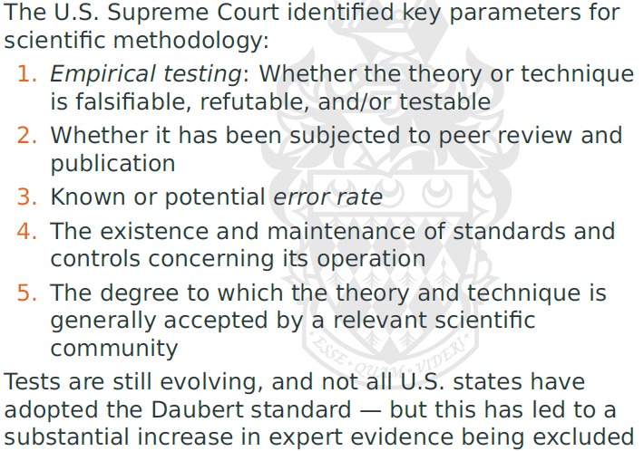

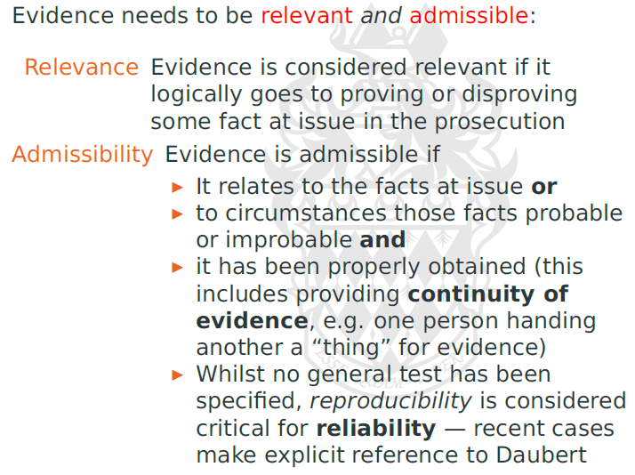

**Technical VS Expert Evidence**

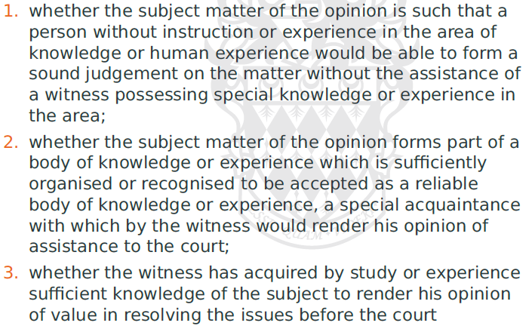

Expert 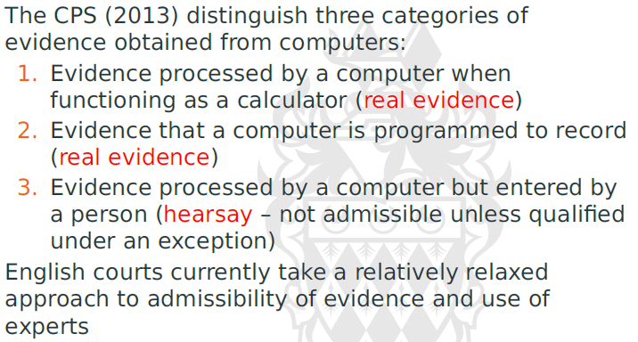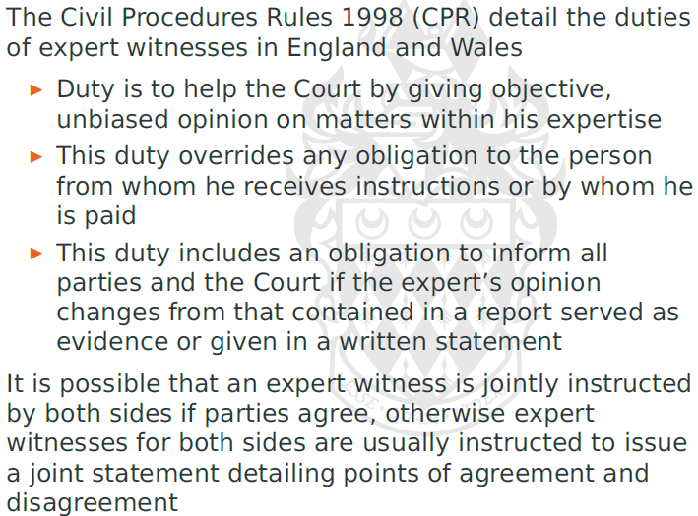

Contents: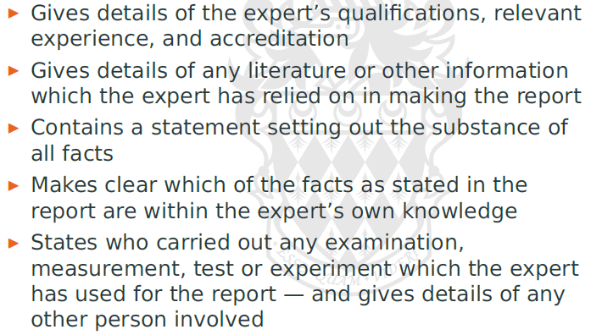

Digital Evidence:

* Complexity of underlying tech
* Distributed (botnets), obfuscated C2 channel
* Witness = other coms, more objective. Can be manipulated too
* Very fragile = accidental/deliberate change of evidence

**Electronic Evidence Principles**

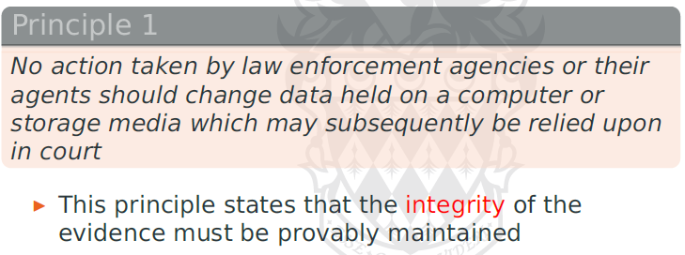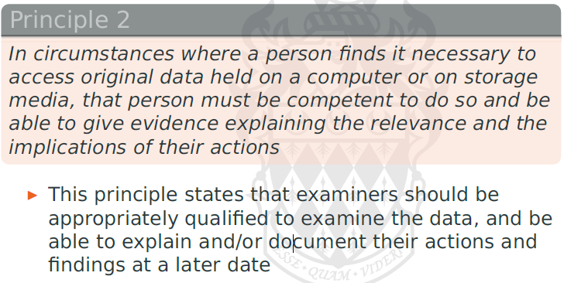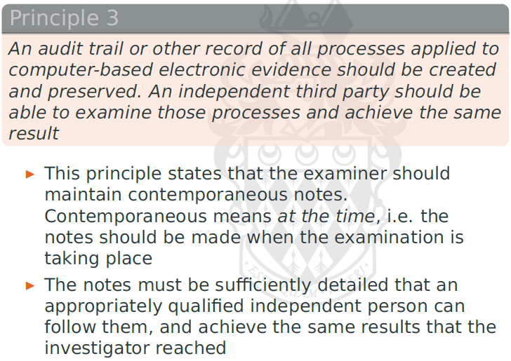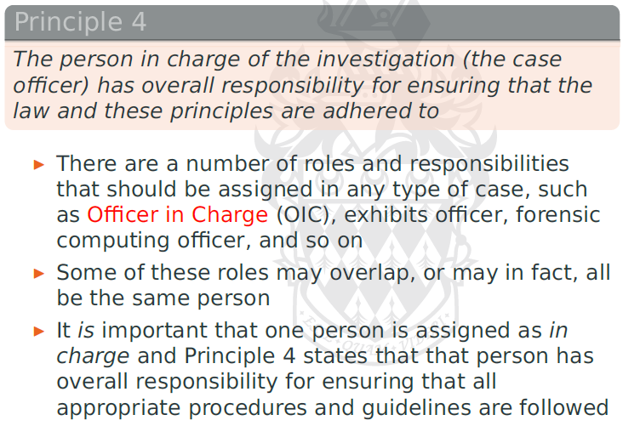

Standards:

* ISO27000 series: 27037:2012
* US got manual
* Scientific Working Group on Digital Evidence (SWGDE)
* UK = ISO17025:2005

1st Step:

Freeze Scene:

* Photograph, CCTV, fingerprints
* Physical articles (all devices with mem) in sealed bag
* Witness
* If com switch off – don’t switch on
* If com switch on – don’t switch off

4 stages of investigation

1. Collection
2. Examination
3. Analysis
4. Report & Statement

*done by different ppl (chain of evidence must be maintained)

Collection

* Depends on type of device/ vitality / network data
* Most = involve computer –based, digital evidence – will involve networked device
* Further complication = user with multiple devices
* Win 10, Microsoft can collect all data

Mirror Image Copy

* Bit-by-bit copy (tool must be common)
* Use of Write-blocking device (so wont overwrite)
* Use of crypto hash functions and checksums
* Use to verify
* Specialised device/equip
  + Different connectors, specifications
  + eSATA Write Blockers

Forensics Image Tools

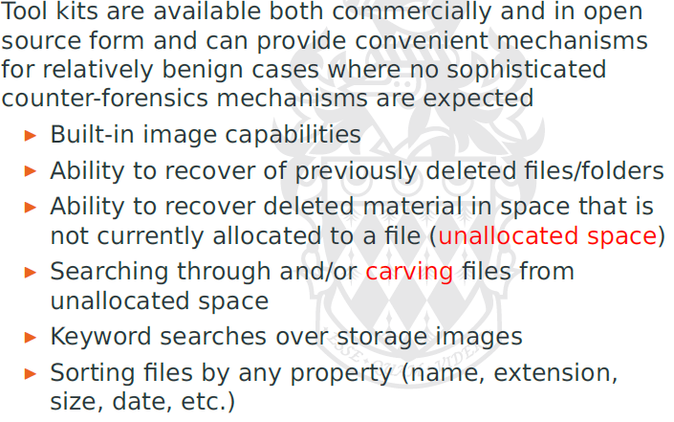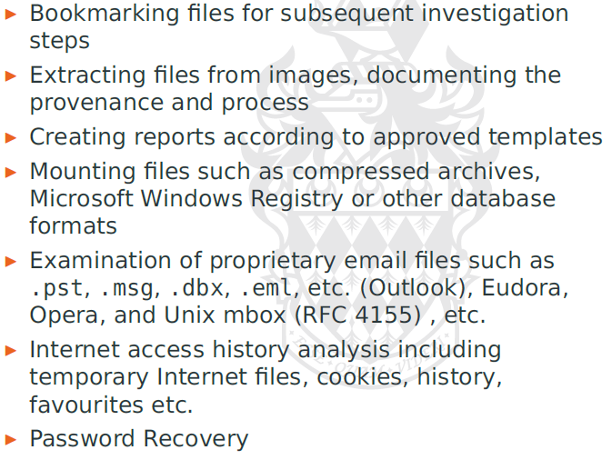

Common mistakes:

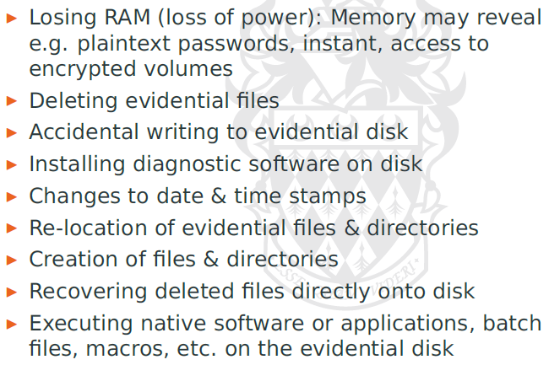

Continuity of evidence: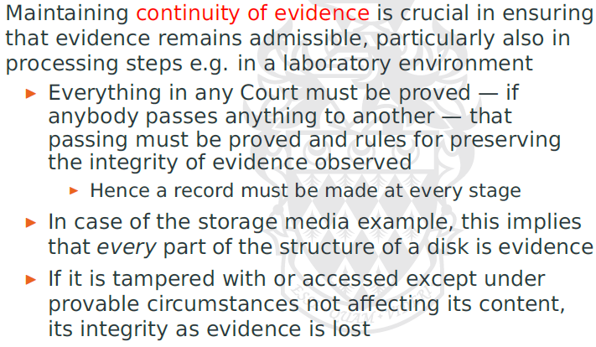

Active live systems:

* rich sources of additional evidence
* reading physical memory through external devices

Techniques exist for copy volatile memory contents

* VM snapshots
* Hardware debuggers, in-circuit emulators
* Exploiting hibernating mode feature
* Exploit crash drump
* Require sync between multiple memory subsys and protective mechanism

Computer Evidence Factors

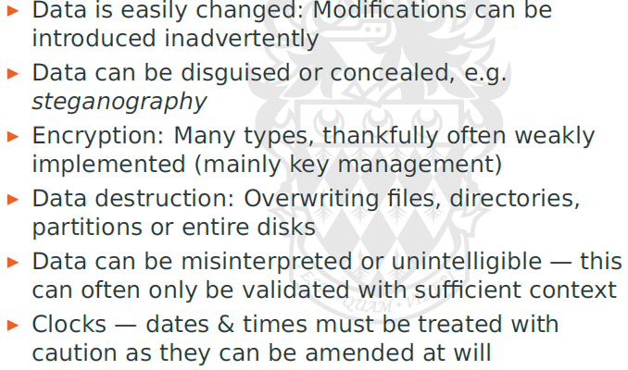

HDD, need strict procedure:

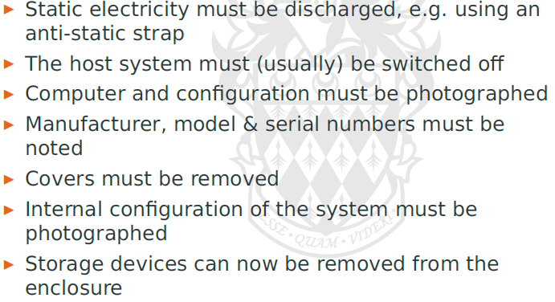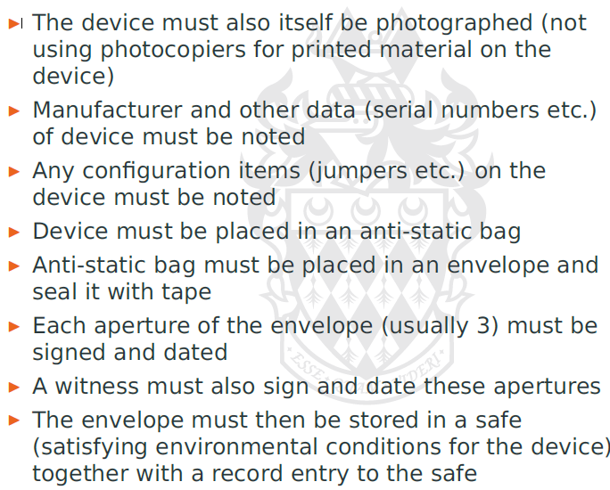

Examination Phase

* Technical review conducted under reproducible lab conditions
* Critical goal = data reduction, separate wheat from chaff
* Needs to include system timestamps

Analysis Phase

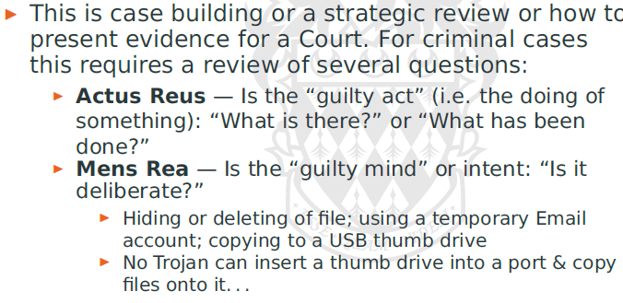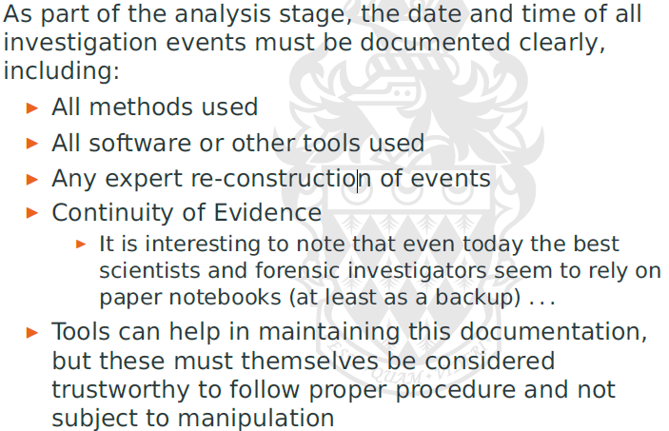

Not always the case that principles = followed

Live CDs/pen drives

Anti forensics devices/tools = obfuscate/remove evidence

Unit 2: Storage Media

Capacity = increase

Transfer rate = not so much

Controllers = maintain map of physical disk

Divided into Cylinders, Heads, Sectors

Later changed to Linear Block Address

Modern = virtual CHS or LBA interface

Modern disks = non-uniform sector sizes and numbers at different tracks = maximize density

Harddisk = (new) OS inside, and communicate with the real OS (not just space).

Controller logic = resides on disk  
interface to computer system = host bus adapter only

* Specialized componenets
* Motor and actuator controls, signal amplifiers, transceivers for HBA
* Signal processing for R/W channels
* Mutli-core system on chip = real time OS
* Must schedule mechanical movements and R/W ops to maximize throughput params
* Adv components = crypto processors
  + Self enc drives

Substantial amount of cache memory + flash memory also fitted

Volume Management

* Requires support from hardware and firmware
* BIOS, simple scheme for partition, MBR

Original MBR = CHS spec, LBA supported

Max size = 2TB

MBR = 512 bytes in sector 0 of driver

* Partition table
* Bootstrap code
* Time stamp and signatures

New = UEFI and GUID partition (GPT)

* GPT uses LBA and has GPT header
* Each partition entry own type and GUID

UEFI firmware = boot manager app can be configured to identify and boot from arbitrary partition, without cascading boot loaders

* Like separate OS
* Provides boot and runtime services
* Includes device drivers and graphics interface
* Allow network booting
* Secure Boot = verify against platform key

Disk (Encryption and Forensics)

* Some countries = key disclosure law (force cryptographic key material to be revealed)
* May resort rubber-hose cryptanalysis (force it out of ppl)

Hardware-based full disk encryption

* Addition to ATA Drive lock – easily removed as password stored in drive service area, can be overwritten, flag disabled
* NOW = encryption = AES-128/256, where key is not revealed by drive
* Protects data-at-rest on self-encrypting drive
* Can use for cryptographic erasure

TCG Opal spec = separate authentication as well as **key escrow** for key recovery

* Any valid authentication = allow media encryption key to be unlocked

(stays unlocked until power down)

Can allow pre-boot authentication (multi-factor auth) or key management software

SED = show virtual view of disk

FAT File System

Block Oriented:

* Sectors (all low levels occurs on sectors)
* Clusters (grouped, to be manageable, varies, often with actual file system size)
  + Not zero-ed when removed

FAT12, FAT16, FAT32

FAT Volume = divided into Reserved area, FAT area, Data area.

FAT12/16

* Special Root Directory
* Extended BIOS Parameter Block

FAT32 (Further structures)

* sectors per FAT
* cluster num of root directory start
* sector number of file system
* volume labels
* sector number of boot sector backup
* serial number of volume (cant rely)

FAT Table Structure

* file allocation chains (link to next cluster)

FAT Directory Entries

* flag attributes

ExFAT Directory Entries

* high-capacity, slower storage systems
* minimize frag, can reserve data by pre-alloc clusters

Linking FAT Data Structure

FAT Fragmentation (highly resource-intensive)

Securing Evidence

* circumstances varies (office to violent crimes)
* photographic evidence
* can come in different forms (USB, digital photoframes)
* original evidence remain undisturbed
* any investigation = accurate duplicate

Forensics duplication

* forensic duplicate (file with every bit of info from source in raw)
* qualified duplicate (same info as forensic duplicate, contains further embedded metadata, or use compression)
* restored image (restored to another medium)
* mirror image (bit wise copy from one to another)

Creating it

* device = must ensure no write
* imaging device = perform sector-by-sector copying
  + error must be identified clearly, logging
  + integrity of duplicated must be tracable (using hash)
* time, location of duplication session
* Diagnostic info from device   
  (serial, firmware, revisions, SMART)
  + No. of startups
  + Temperature

Assurance issues

* Write blocking (assurance)
  + Expert testimony
  + Forensics lab provide test results
  + Accredit these devices
  + Special hardware = Simple to implement, easy to validate

Volume sys = combine multiple sub-volumes into single

* All components = required for duplication (identified, recorded clearly)
* Aggregate volume, config = needs to be recorded
* Complex sys, storage area network = extremely hard
* Identification of storage locations, for logical, hardware volume

May contain slack space (unallocated)

* Can be used by arbitrary file systems (must be analysed separately
* Counter forensics tech
  + Rely on allocation strategies
  + Overwrite space in volume that is known (assumed to be unlikely to be overwritten)
    - These also must bypass existing file system

Reconstruction tech

* Used in some ways?
* Deletion occurred?
* Wiping occurred?
* Counter forensics?
* File system format known?
* File system complete?
* Knowledge of file content/format available?
* Sought-after info replicated?

Reconstructing FAT

* Finding boot sector signature in reserved area
* Damaged, but structure can be hypothesised
* Identify 1st cluster (if exact FAT type and cluster size known)
  + Cluster allocation strat may vary
* Directory entry located (transverses chains of directories)
  + Base entry must be identified
    - Hold starting cluster
  + Long filenames (multiple entries exist)
  + Alloc status (0x00=blank, 0xE5=deleted)
  + New directory = 0-wiped for . and ..
  + Chained list to EOF
* Deleted = deletion of first byte of dir entry
  + Ambiguity of filename
  + Long file name entries (used to reconstruct)
* More problematic (directory deletion, and realloc)
  + If directory entry = zero-ed, files = orphaned
  + Recovery requires use of heuristics for file/dir struct

Forensics Analysis

* Cluster info avail = straightforward (or else content-specific heuristics)
* Re-used clusters, data in slackspace may remain, until overwritten

Beginning of undamaged disk (can see boot sector)

Backup FAT copy (after 523 sectors X 512) at offset

* Identify directory offsets & entries
* File contains 33 sectors
  + Cat get magic number of files
  + First byte of deleted = E5
  + Identify (.) and (..) for directory

Storage architecture

* I/O subsys
* File sys
* Volume snapspot manager
* Volume manager
* Partition manager
* Miniport driver
* disk subsystem
* Custom drivers
  + Class drivers
  + Port drivers
* Hardware

Specialised

* iSCSI (storage area network)
* Multipath I/O (high availability)
  + Affects consistency
* Windows kernel not use drive levels

Miniport = hide lower level functions

Windows Volume Handling

* Partition 0 = entire disk
* Logical partition = assigned drive letter (Win API level)
* Some application operate on RAW parititon (skip os file system layer)

Dynamic Disk Concepts (RAID)   
Redundant Arrays of Inexpensive Disk

Virtual Disk Service (VDS)’s Logical Disk Manager (LDM) = single DB

* Resides in reserved space (1MB)
* Dynamic disks’ GUID, name of host, transaction log

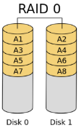RAID 0: Striping

* No redundancy, increase failure rate
* enhance performance
* allow grouping of disks

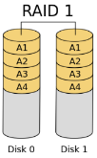RAID 1: Mirroring

* Enhance reliability/performance

RAID 5: Block-level Striping

* Parity data distributed across all disk
* Reduce overhead, enhancing reliability
* 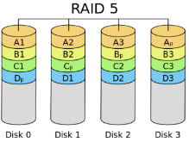Performance = dependent on parallel block access
* Use XOR to recover the rest

Windows Volume Shadow Copying

* Allows snapshot of file sys
* Clone shadow copies
  + Live and mirror volume (only live is writable)
* Copy-on-write
  + Differential copy only retains changes to live data on shadow

VSS

* Both system restore & VSS = differential
* Window >=8, VSC offered, requires 2nd drive to extract shadow code
* VSS = restore points

File History Service

* Internally = journal/differential structure, but on files, not blocks
* Acts as backup service. Includes user data.
* Allows forensics/regular user
* Requires use of NTFS
* Change journal on alternate data stream
  + Files saved with appended timestamp
* If external storage != exist, then cache used
  + Backup volume connected, moved
* HELPS forensics investigator IF NO deliberate deletion

NTFS

* Implementation = 64bit cluster = max 128TB
* Created ReFS(resilient file system), non-bootable

NTFS FS Features  
advanced features over basic FAT

* Data Streams
  + Multiple attributes
  + Default stream = contents
* Indexing
  + File attributes (including security, stored in single stream)
    - indexable
    - do not require linear search
* Remapping  
  fault tolerant, read failure = mark “bad”, new instance created.

No “good” = mark “bad” = cannot retrieve data

* Hard links: for files, not dir
* Sym links: for files/dir
  + dynamic strings interpreted at runtime
* Compression & Sparse files
* Change logs
* Volume Quotas
* Encryption (EFS)
* POSIX semantics (file names compliance)

Change journal (not enabled by default)

* Sparse metadata
* Track info on (CRUD)
* Log file = global, shared among apps
* Access via WIN32 API calls

NTFS Structure

* Proprietary
* Ability to forensics = affected
* TOP-level = $volume metadata file
* Can be single/spanned
* Own metadata (not visible by driver)
  + Can apply basic windows object security mechanism
* CORE = Master File Table (MFT)
  + Array of file records, 1KB (irrespective of cluster size)
  + Each volume = set of medatadata files
    - Begin with $
  + Many attributes = more space require
    - BASE FILE RECORD = location of other MFT entries
* Mounting = reads metadata struct, construct in-memory data struct
  + Volume boot sector provides physical address of MFT
  + MFT = always first entry (2nd=MFT mirror)
  + Mirror = some records, assist if corrupt

NTFS Cluster size

* Default = small
* Individual (current partition) = max 2TB
  + Can use multi partition

MFT Structure

$MFT  
$MFTMirr  
$LogFile  
$Volume  
$\  
$Bitmap  
$Boot  
$BadClus  
$Secure  
$Extend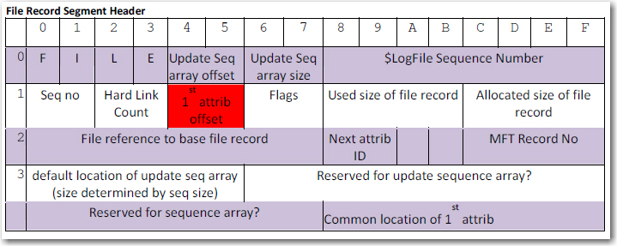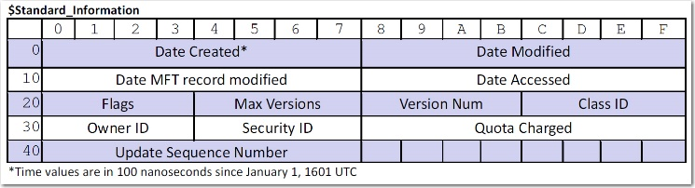File reference num & Record

* Files = uniquely identified by 64 value (file reference)
  + File & sequence num
  + Position of the base record in the MFT minus one (48 bits)
  + Seq num (16 bit) incremented on each reuse of MFT entry

NTFS file attributes

$SECURITY_DESCRIPTOR  
$DATA  
$INDEX_ROOT  
$INDEX_ALLOCATION  
$ATTRIBUTE_LIST  
$OBJECT_ID  
…

Resident & non-resident attributes  
- NTFS tries to pack all into MFT record  
- entries inside MFT = resident attribute  
- attribute header, attribute value  
- header = always resident, value = might not  
- ifdo not fit, runs/extends are allocated.

Creating/Writing a NTFS file

1. Read volume boot sector, to determine MFT location
2. Read first MFT entry, determine MFT layout
3. Allocate MFT entry for file
4. Initialise MFT entry with $Standard_Information, set flag to “in Use”
5. Given file size, find free clusters (best fit), set $Bitmap to 1.
6. Write file content to cluster, $Data = starting address of cluster run, run length(s)
7. Read root directory, tranverse, find matching dir
8. Read $INDEX_ROOT for dir
9. Once correct index entry = found, create new index entry, re-sort (balance) index tree

INDX data struct = reference to MFT record, (CRUD, size, filename)

NTFS forensics rely heavily on INTACT INDX struct

NTFS Recovery Mechanism

* Volume (metadata) consistency = maintained using journaling mechanism
* All volume altering = logged = transactions
* Cache flushing (consistency ensured)
* Log = by Log File Service
* RW, flush ops by LFS run through cache manager
* Actual volume ops = by FSD (through cache manager)

1. NTFS FSD calls LFS to record transaction (cached)
2. Modifies volume (cached)
3. Cache manager at some point request to flush log
4. Volume changes are written out.

Fault detection mechanism flag inconsistencies = run chkdsk

1. Detect corruption
2. Online self healing
3. Online verification
4. Online idenfication & logging
5. Precise & rapid correction

*hinders forensics, cleans up everything. Malicious user can use bad sectors to store files.

Self-healing NTFS

* See “bad sector” notifications, remap clusters containing bad sector
* Detect corruption flag, worker thread try to repair file system damage based on logs
* Spotfix will come in if cannot handled online, repair require volume to be offline

NTFS File Deletion

1. MFT located
2. First MFT entry is read, reconstruct MFT layout
3. Root dir read, index traversed, until dir entry
4. Dir hierarchy tranversed
5. $Index_Root struct read, to get target file
6. Target file removed from index, data struct re-balanced
7. MFT entry unallocated, in-use flag zeroed
8. Corresponding MFT $Bitmap, zeroed  
   All steps in logs

<SCREENSHOT FROM SLIDE 57>

EFS – encrypting file sys  
Bitlocker – volume encryption protected (usb/TPM)

EFS = file system filter

* Encrypted individually with symmetric cipher
* Randomly generate key, use PK cryptosys, stored alongside encrypted file in $EFS alternative data stream
* Reading, certificate retrieved, FEK = decrypted with matching key
* Per – file basis, encryption attr set on folder, and inherited
  + File and dir copied within an NTFS volume remained encrypted

EFS limitations

* Key management (management of public key including recovery keys)
  + Recover agent compromised, have access
* File System transition = Copied to FAT, it will decrypt
* Intend to protect “data at rest”
  + Still can exist in paging, printing spooling subsys, hibernation files, temp files
* Client side mechanism, key management issues can be addressed using smart cards
* Can recover plaintext via other locations

Bitlocker (complement EFS)

* Volume encryption
  + Requires boot volume to be unencryped
  + Key = usb, password, pins, TPM

Hardware req = full support

* Key(Escrow) stored in MS account
* Strict req = prevent cold boot, preboot attacks
  + Need Secure Boot, Windows trusted boot

Windows Device encryption

* Automatic activation
* Master key = not protected, admin = generate recovery key
* AD GP must be used to store data
* Desktop = not supported usually (mainly phone/tablets)

Bitlocker Vulnl potential

* Requires preboot env to perform
* Potential bootkits, modifying bootloader
  + Malware might inject into mem

Physical Storage artefacts in Magnetic Meida

Low level artefacts

* Modern disk = separate OS, with SMART
* Tools & statistics = useful evidence
* More interesting = from forensics, counter forensics (modification of firmware)
* Allow access to BAD blocks
  + Might not be copied bit-by-bit with the bad blocks

Hybrid drive = Different methods

To recover:

* Relevant dmg component = transplanted from donor drive
* Defective = can be replaced
  + Calibration = critical
  + Physical destruction
* Problematic in straightforward recovery, FAR more in legal dispute (reliability of evidence)

Physical Destruction

* Needs very high temperature to destroy disk.

Low-level Artefacts

* Extensive damage, still can recover
* Platter placed on spin stand
  + Scanning electron microscopes, detect magnetisation

Counter-forensics

* Degaussing
  + Needs a lot more electricity to destroy it
* Crusher
* Chemical Destruction
  + SSD can survive crushing/shredding (bits can allow partial recovery)

**Unit 4: Windows forensics**

Windows Kernel

OS= abstraction layer

* Simplication of interactions
* Emulation
* Multiplexing

Kernel revision = minimal (win 7 to 8)

Universal App = can run on diff Win platform

* Parallel user mode layer
* UAP = sandboxed

OS functions

* Scheduling (priority, deadlock, fairness)
* Memory management
* Storage management
* I/O management

Design Approach

* Privileges = rings/modes
* Graphics = moved to kernel

Hardware Abstraction Layer

* Abstraction to upper kernel layers
* Requires other kernel components to function
* Activities at firmware/chipset > OS, lowest layer in OS

Micro kernel

* Multiprocessor sync
* Thread & interrupt scheduling
* Dispatching
* Trap handling

Executive Components (conventional kernel, core services)

* Object Manager
  + Objects to encapsulate most resources
* Configuration Manager (registry
* Advanced LPC
* I/O manager
* Cache manager
* Process manager
* Memory manager
* Power manager
* Plug&play
* Security Reference Monitor (security policy)
* Kernel-mode driver (graphics)
  + USER (keyboard,mouse,msg)
* Hypervisor Library
* Kernel Transaction Manager
* Kernel Debugger Library
* Errdata Manager (workaround for nonstandard hardware)

**I/O Architecture**

* Insulate sharable resources, provide abstractions
* Dynamic loading of device drivers
* Provide layered device drivers for extensions
* Support installable file sys
* Implementation = multiple components

I/O Components

* I/O manager
* Device driver
* PnP manager
* Power
* WMI (windows driver model)
* Registry
* Configuration files (.inf)
* HAL

I/O flows (image) – API-to-API  
can be messy as happening in parallel

**Windows Device Driver Architecture**

* User/kernel mode
* Virtual device drivers
* Printer drivers
* User-mode driver framework

WDM windows driver model

* Bus driver
* Function driver
* Filter drivers

3 categories of device drivers

* Class drivers (minor adaptation)
* Port driver (requires processing)
* Miniport driver (device specific)

File access (layered)

1. User mode = NtWriteFile
2. System translate call to I/O manager
3. I/O manager Instructs file system driver (FSD) to write via file offset
4. FSD translates to volume relative via I/O manager
5. I/O calls disk driver
6. Disk driver translate to disk-relative offset and write

Display Driver

* Offload computation to GPU
* Win 10 = GPU virtual addr
* can access main mem directly (but NOW = WDDM will manage virtual mem)

Configuration DB (Registry)

* separated into multiple DB based on usage
* custom = use .ini
* may use RDF

Registry

* use KEY and VALUE
* HKEY_CURRENT_USER (data associated with logged on user)
* HKEY_CLASSES_ROOT (file association and COM object registry info.)
* HKEY_LOCAL_MACHINE (sys related info, security)

AD and GP

* User auth and data via AD
* Extended of LDAP
* Kerberos, DNS, network admin
* Organisation = domains and forests, can replicate)
* Local config db, and auth = SAM

**Windows Live Forensics**

REASON: (any OS)

* Current contents with live (volatile info)
* Assistance with static
* Obtain pw, key, unencrypted data
* Reconstruct session, app info
* Network traffic and app
* Investigation = conducted clandestinely
* Mission critical = cannot shutdown

BENEFITS

* Pw, crypto, app data = retained
* Most app not designed to minimize exposure of sensitive data
* Mem released, not overwritten (perf issues)
  + Large amount of RAM
  + Can leak info in crash dumps

LIVE imaging tech

* Physical memory access, dump memory content
* Implies sync, locking, not always feasible/desirable

2 key problems:

* Volatility (some bg still would be running)
* Artifacts (obs conducted, will leave smt)

Tools:

* Sysinternals
  + Networking
  + Security
  + Processes
  + System info
  + File & Disk
* Disk2VHD = capture image into virtual disk
* Sysmon= logging of process
* Prodiscover IR
* Encase, FTK

Possible pitfalls

* Tools require acquisition through regular API
* Adversaries can alter any of these API

Crash dumps (BSOD, valuable info)

* Same problem as above
* No consistent kernel virtual memory dump (unless system halted)
* Can use commercial tools

Can use hardware tools as well

**Windows Security Architecture**

Security functionality, spread out across components in windows

* Security Reference Monitor
* Local security authority
* LSASS Policy Database
* Security Account manager (SAM)
* Active Directory
* Authentication Pacakages
* Winlogon
* LogonUI
* Credential Provider
* Netlogon
* KSecDD – kernel security device driver (library implementing LPC to kernel security, e.g. EFS)

**Access Control Mechanisms**

Object based design of windows

* Entities as object
* System resource exposed to user mode
* Accessed via Object manager (maintains name spaces and handles)
* Any access = based on specification of desired access priv
* Names = ambigious, windows use SID

SID = unique

* machine = issued with SID
* accounts/deriatives = derived from source SID
* Domain = relative security identifiers (based of DC)
* Well known SID = predefined roles, Everyone role
* Cloned machine = SID need to be adjusted
* Every logon = unique logon SID
  + Generates unique access token
  + SID for logon session = fixed, RID = randomly generated
  + Used to specify integrity level
    - Untrusted – System

Access Token, security descriptors

Token = identify security contexts of process/threads/sessionID/priv/groups/accounts/integrity levels/ UAC virtualisation state

* Initial token = created on logon, inherited, can be modified/filtered
* Impersonation = temporarily change security contexts

Objects = Security Descriptors (contain owner + groupSID), Discretionary Access Control list(DACL), System Access Control list (SACL)

Audit Mechanisms

Multiple ways = generate audit events

* Object manager = generate result of access checks
* Kernel level code = generate audit record
* User level code = generate auit record, but priv set in object SACL

Audit = controlled by Local Security Policy, maintained by LSASS, executed by SRM

* SRM = generate audit event, send to LSASS via ALPC

Event Log Architecture

* Old style = 3 sources (system, application, security)
* Now = XML based format
  + Allow more context, extensible number of event log types
  + Easier with XML format

Remote Event Log

* Major drawback (before 6.0 kernel) = lack of event forwarding
* Now = can be reviewed remotely or logged centrally
* Format = portable, EventManifest schema = allow complex event format

**Virtualisation**

Isomorphism from guest state to host state

Hardware must assist VM monitor (insulate VM)

* Control over physical hardware interrupt
* Allow VM to violate isolation boundaries
* System instruction = emulated by monitor on software
* Guest state = kept in meory
* Guest system instru = implemented as functions within VM monitor

Objective of CPU virtualisation

* Process all unpriv instru unchanged (ASAP)
* Emulate all priv instru
  + Simple/straightforward, but need to be fast

Alternative = Trap and Emulate

* Priv instruct from guest VM = priv state (TRAP)
* Only if all instruc execute normally

Problems with Trap and Emulate

* Not every instruction set architecture support
* Cost of trap = high,
* VM monitor requires use of priv level for trapping
* Protection levels in guest VM = virtualised
* Priv instruction = can access other VM/host (assurance = from software)

Alternative = Binary Translation

* Code analysed a priori on the fly & translated
* Priv instruction, sub with code causing desired effect (no effects on physical hardware)

Problems with BT

* Sync of PC with interrupt
* Handling of self-modifying code
* Complex ISAs = internal state needed to be maintained

**Common Virtualisation Properties**

Provide Guest BM with

* Virtual mem env
* Device/virtual driver, multiplexing hardware, emulate devices
* Images of one/more file system

Interactions among host, and guest. Device driver = different behaviour

* Counter forensics = make use of this = detect running if running inside a sandbox (or if research labs) = self destruct
* Forensics for cloud based system = hard

Hyper-V

* OS support for virtualisation
* Allow running in a guest partition (adapt behaviour accordingly, avoid inefficiency)

Others = VMWare, Xen

**Unit 5: Memory & Live Forensics**

2 broad categories

* **In-system Acquisition** (software based, collect RAM)
* **External Acquisition**

Analysis on memory image (preserve reproducibility, unless dyn behaviour needed)

**In-system = alter state of system to be acquired**

Counter forensics present

* May prevent accurate acquisition, even with tamper resistant components
* More problem in actual LIVE forensics

**In-system**

* Key problem = not possible to freeze
* Memory snapshot = takes time, even if can stop all concurrent processing unit
* Not all system state can be captured reliably
* NOT completely atomic

Achievable atomicity degrades if amount of memory captured = increases.

Effect on integrity of memory image (e.g. data altered after snapshot time)

**Live Forensics techniques**

Basic techniques = (not different from OS)

* Require knowledge of kernel structure, process life cycle

String searches (carving): extract strings from live memory on images

* Encoded in different ways
* Signature matching, fingerprinting to identify in-memory structure ad objects

Further = understanding of kernel structure

When taking mem dump, info on OS, kernel, patch lvl = required

* Exact system config (device driver)
* Identification of key data struct = by location/content
  + Backwards resolution of VM page table entries
  + Some structure= useful for further entries
  + Not everything deleted, process struct can be recovered partially

Page swap = not only payload, structural info

* Page dir, table entries = paged and highly useful in reconstruction in physical memory dump

Direct Kernel Object Manipulation (DKOM) = not perfect, leaves artefacts

* Leave traces, inconsistent data structure
* Process not in processlist must still run = traces in memory management subsys
* Snapshot = inconsistencies in kernel image, known semantics, live image

Persistence of data struct (1GB)

* Windows = 3 MB left after 14 days
* Linux = 7KB(busy), 23KB(normal) after 14 days
* Systems = retain info after reboot/reset
  + Extent = model, mem config, BIOS
  + Unreliable, but forensics access can still obtain something
  + Contextual info (system state) = not retained

Memory Acquisition Mechanism

* Use DMA access (prevent drawbacks on software)
* Approach = cross-platform, not dependent on OS
* Approach works on all DMA-capable devices
  + Ability to hotplug
  + WILL change the target system = Plug and play
* PCI powered on, DOES NOT announce its presence (avoid P&P interfering)
* When activated = PCI controller halt the CPU
* Device read all physical memory via DMA to external storage (logging included)
* After finish, CPU restarted, PCI disengages
* Hardware-based mechanism = heavy on CPU, bus, mem architecture
* USB = no authentication
* Identified by interface class, capability, serial number
* Presenting multi-capable OR fraudulent usb = easy

USB-C = charging port. (can expose, can do more stuff, DMA transfer)

Counter Forensics

* **DoS,** attempts to halt/crash system when CF detect acquisition
  + Adverse consequences for investigator. Live = mission critical
* **Covering,** cover parts of memory
  + CPU will see, and process code and data to be covered
* **Full replacement,** more sophisticated than covering. Replace with benign data

**Techniques** for **rootkit concealment**

* **Syscall Proxying,** interposition between system calls, provide several interface for concealment
* **In memory library injection,** dynamically replacing (hooking) code in system lib

Can be detected, by monitoring critical data struct

Common memory image acquisition tool = easy to locate, kill, manipulate

**Target Tools**

Small num of tools = rather than manually trawling through mem dump

* Using common tools
* RE, possible to “trip” up analysis
* Tools = rely on “carving” data struct

Understanding parsing process by tools = manipulation of data struct for obfuscation

* Virtual address translation = tedious to perform, but required as memory image = record physical address
* Must identify directory table data struct and entry points
* Use pointer redirection/ Manipulate data struct (can hide, even if memory acquired)
  + Rootkit = construct own data struct
  + Tools = assume mem corruption, rely on consistency
  + As complexity of mappings, hard to validate manually
  + Delibrately target consistency checks in data struct

TLB = used to avoid penalties of paging hierarchy to look up CPN arch

* Associative caches, for previous page-table lookup
* Tools = utilize fact that code & data use diff TLB = Modification of page fault handler
  + Allows concealment of executing process from acquisition tools = as they use data TLBs

DMA = can be subverted

* Embed memory controller for perf
* Re-program chipset to achieve CF objective

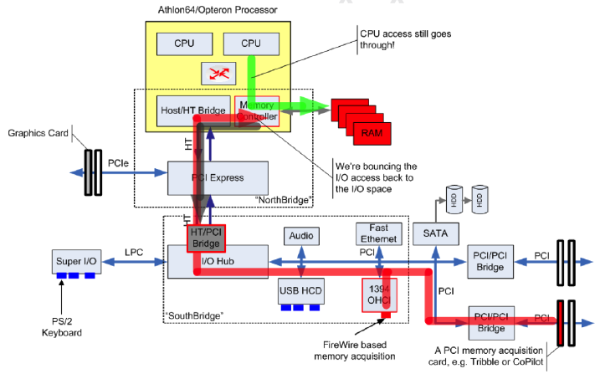

Counter (Counter Forensics)

* A lot of diff chips, harder for CF tools developer (need new tools)
* CCF = needs to keep track of developement
* IOMMU = effective virtualisation support for I/O, side effect = sandbox
* Problems = indv machine config
  + Some mem = use for sending/receiving commands
  + Buses need to be halted, or else manipulated
* GPU memory = interesting (doesn’t exist)
* Crash files or Hibernation files = not all info
  + Crash files = need space for dump

Physical RAM Persistencce

* Magnetic core (super old) = retain contents
* SRAM = retain based on battery
* DRAM = need electricity, need freq refresh cycles
* Probabilistic, and temperature
  + Memory loss over time (temperature cooled)
* Some = self-destruct mechanism
* Time = feature size shrink = ability to perform analyses decrease
* Reading adjacent = might flip bits (tight margins, for accessing mem between refresh cycles)

**Nonvolatile Storage Forensics**

Previously,  
- disks = networked computer system in their own rights  
- external int = pure logical (actual = geometry, caching, defect management)  
- Sector reallocation = increased error rates, predicted failures

Physical damage = spin stand analysis

Solid state memory types

* SRAM (static RAM)
  + No need refresh cycle
  + Data lost when no power, batt backup (mayb sufficient)
* EPROM
  + Programmed data = 10-20 years  
    erased= UV exposure
* EEPROM
  + Electrically erasable programmable ROM  
    no UV exposure
  + Data = 10+ years
  + Small configurable memory
* FeRAM (ferroelectric material = mag charge)
  + Power is used, when read/write
  + Fast write speed, lower power
* MRAM (magnetoresistive RAM)
  + RW = 1ns, still not deployed largely

Flash memory

* 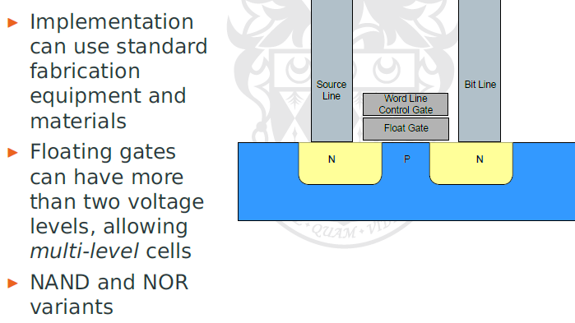
* 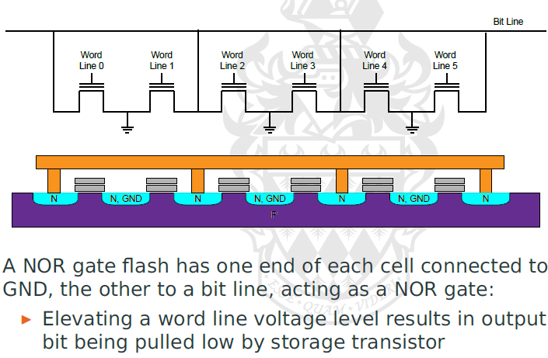
* Writing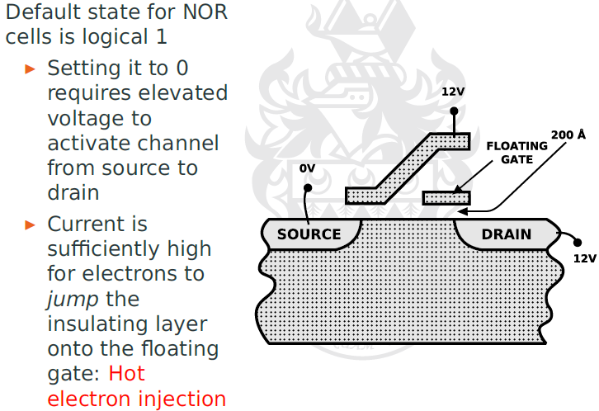
* Erasing
* 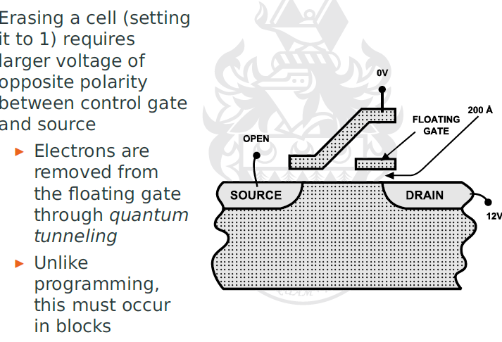
* 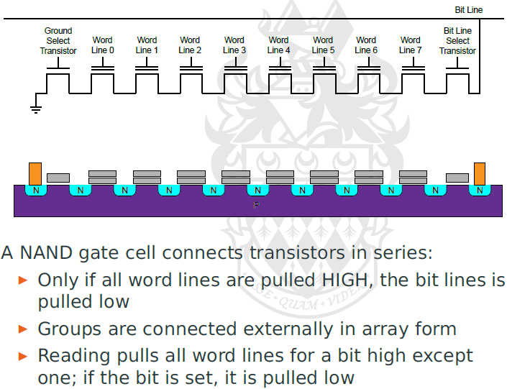

NAND n NOR flash comparison

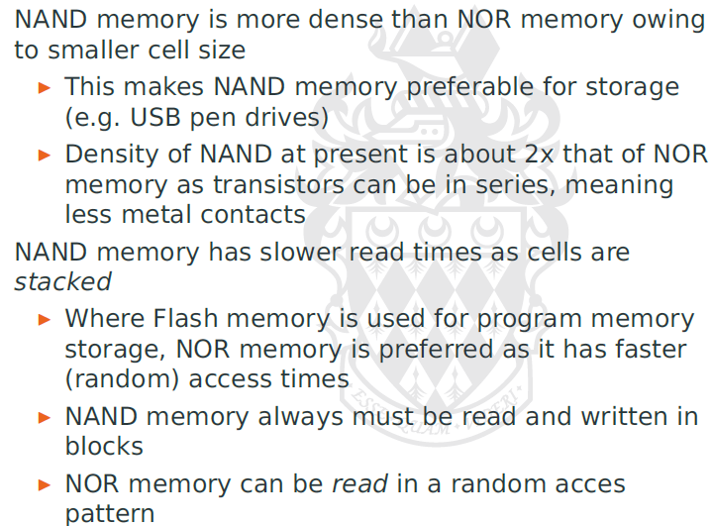

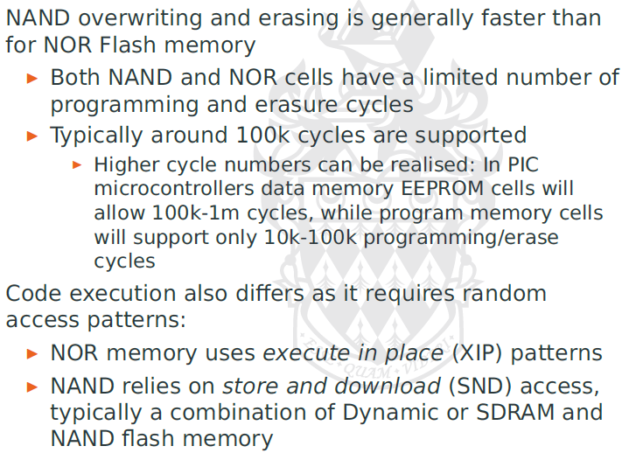

Impact on FS architecture

* Highest = uneven use of storage location (e,g, FAT table & root directory)
* Not built in 512b, but 128kb
  + Divided into pages (64 of 2kb)
  + Emulate mag disk, 512 sector
  + Data area, and spare area (2kb, 16b)

SSD = heavy usage, some manufacture allocate additional spare capacity

Flash File System Adaption = Flash Translation Layer (FTL)

* Translation = make it like conventional mag disk
* Translation of storage = smaller, virtual sector
* Providing appearance of writing (instead of wear levelling)

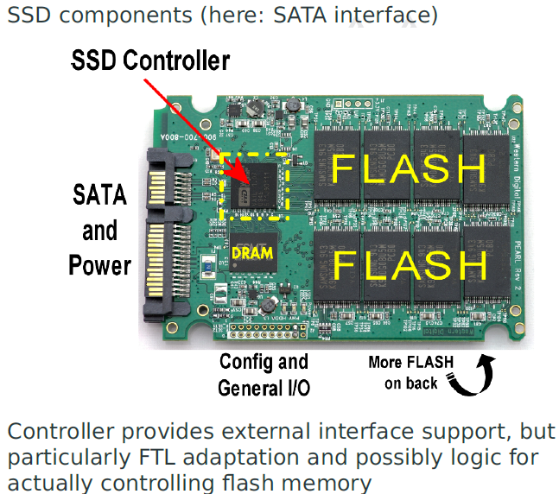

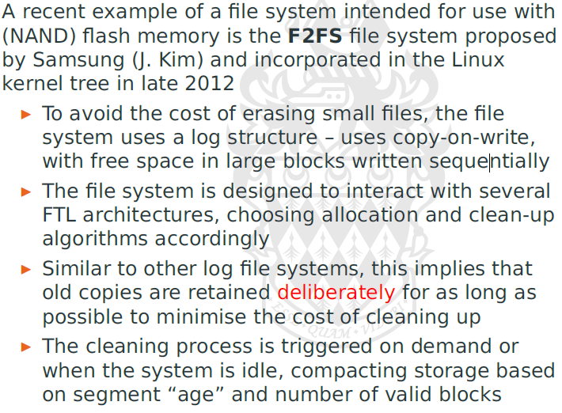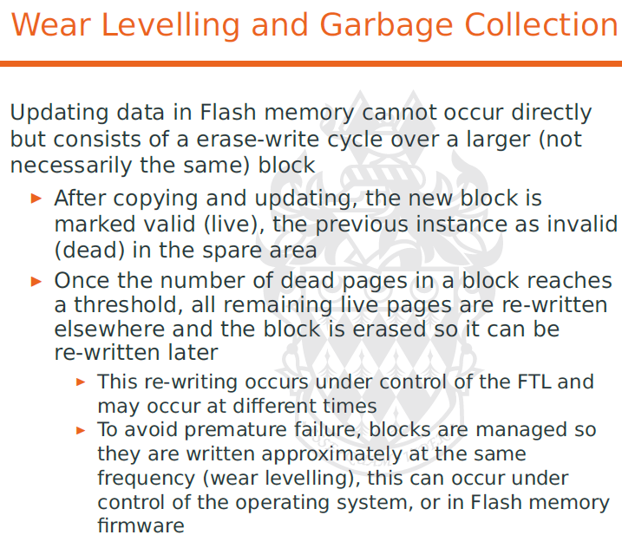

Deletion

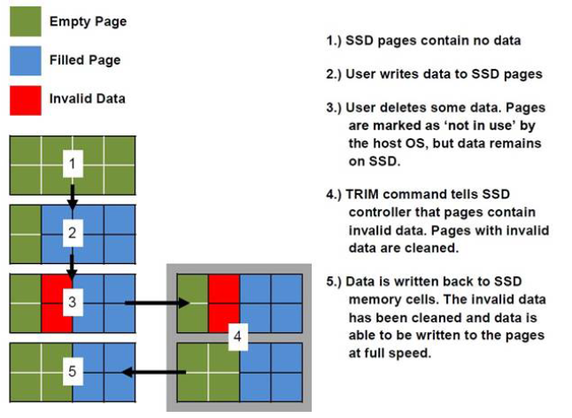

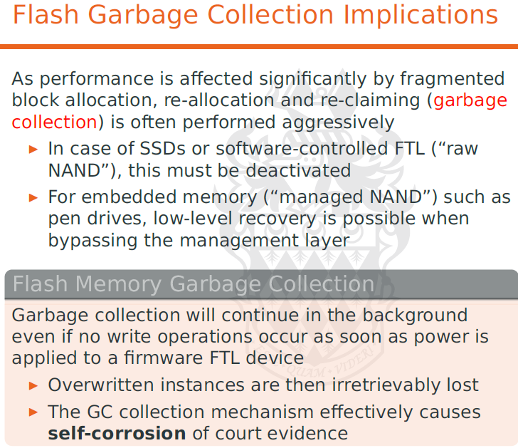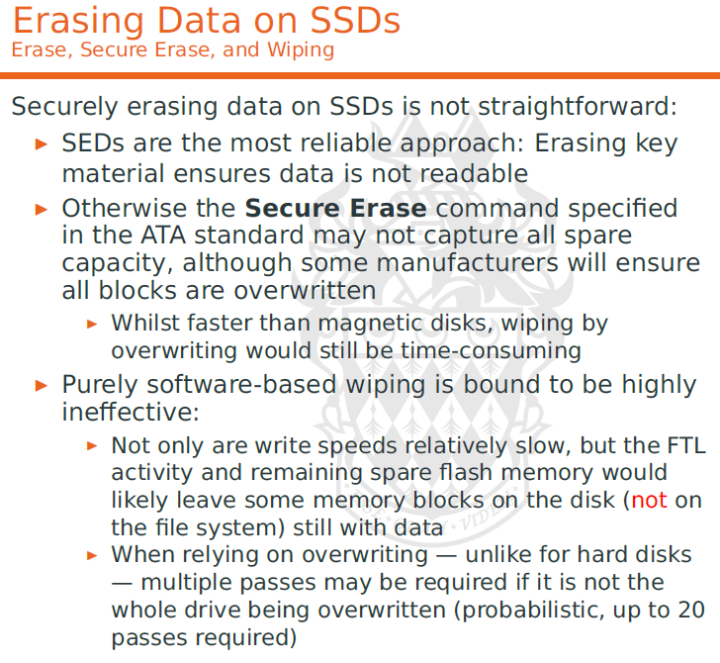

Just remove the key (so the SED cannot decrypt), keep W 20x = melt the disc

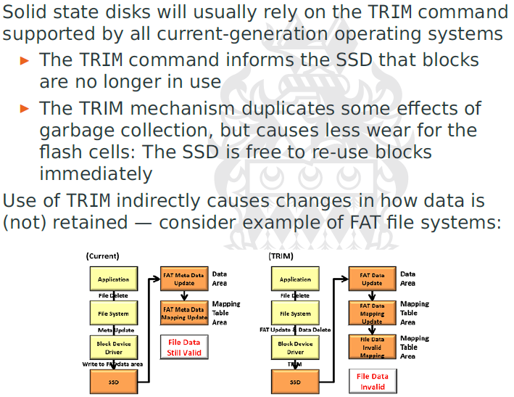

Defect Management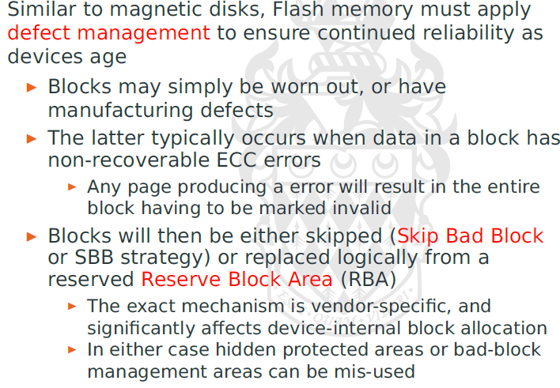

Recovering Flash Memory

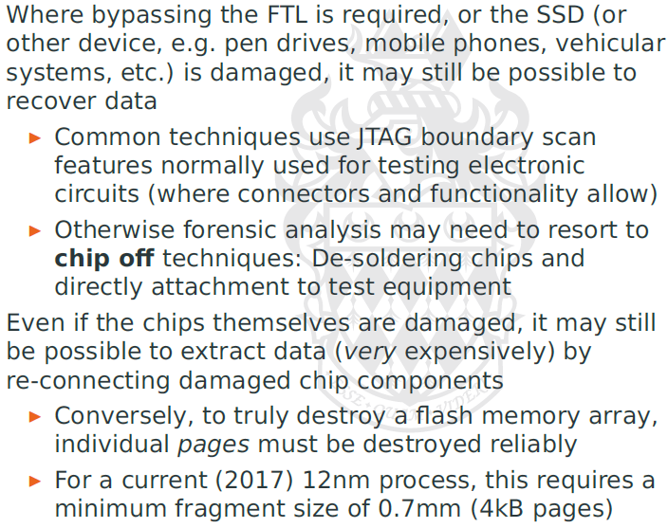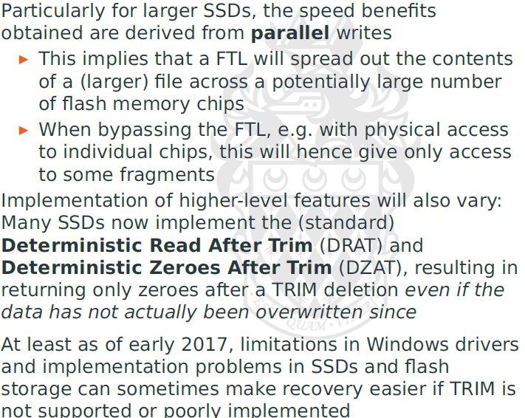

IoT

* Hardware placed in initial state
* Components configured in deterministic (dynamic reconfig of hardware)
* X86

Necessary code = firmware

Can be anywhere (chipset, GPU, storage subsys, network int, energy/power management)

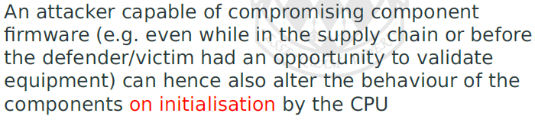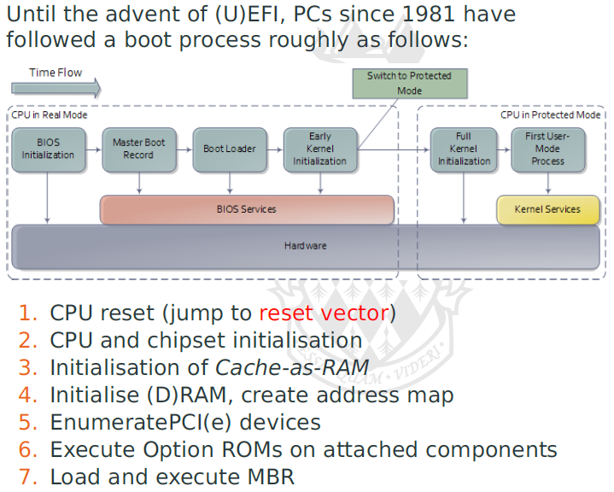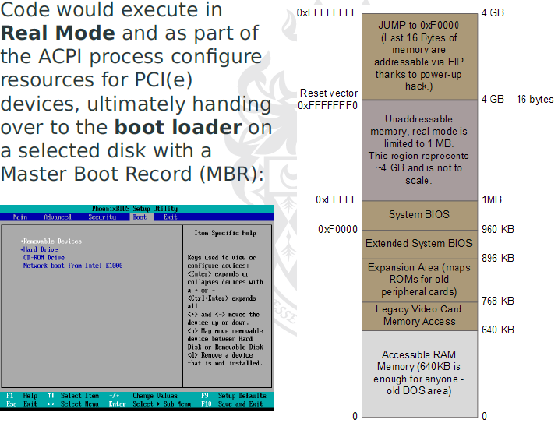

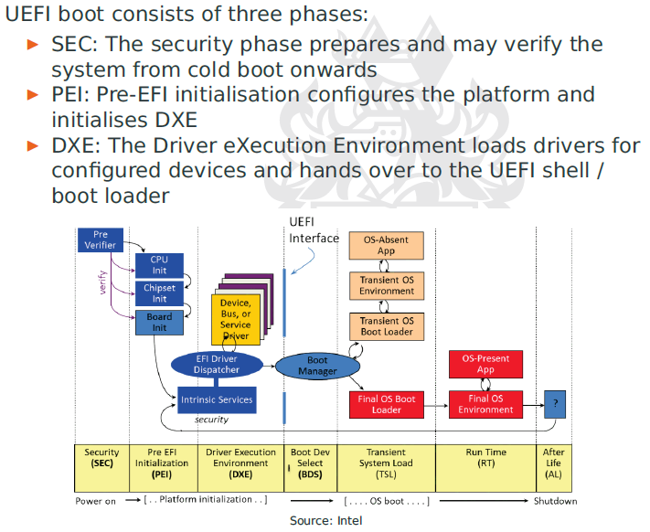

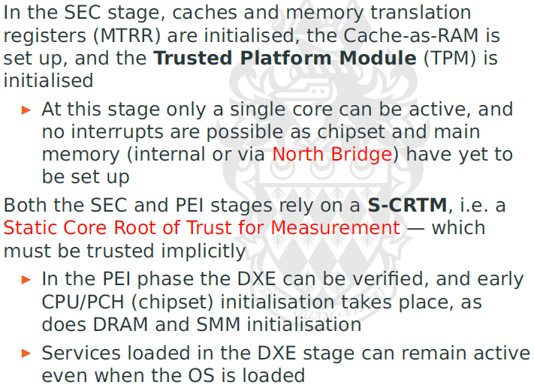

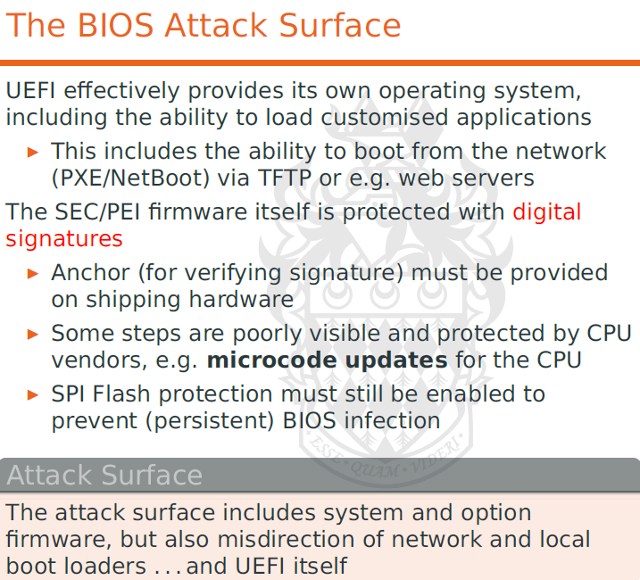

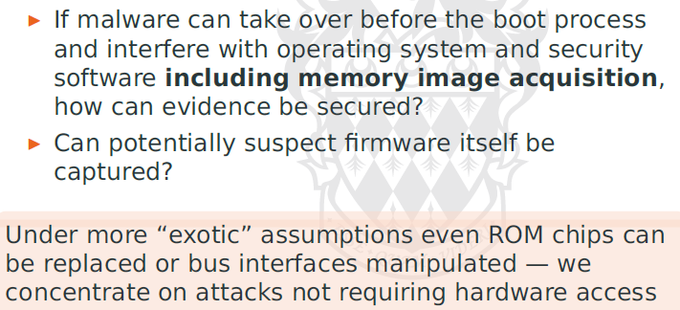

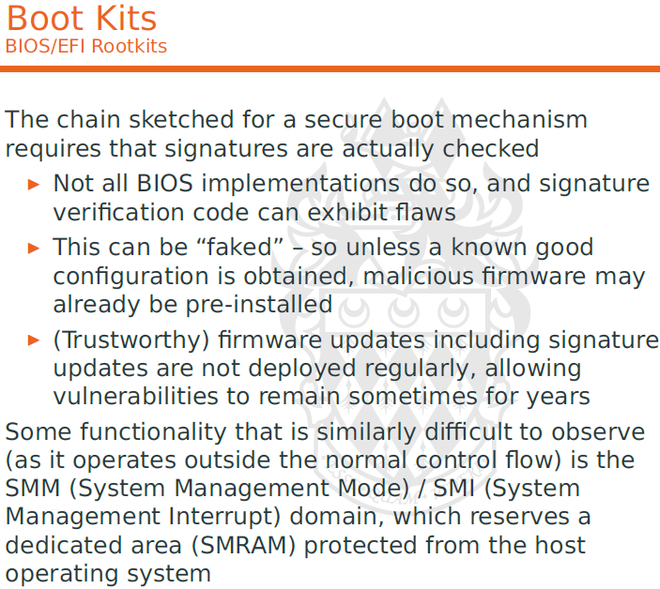

First bootkit = Stoned, resurfaced= mebroot

Intel secure boot (dream boot)

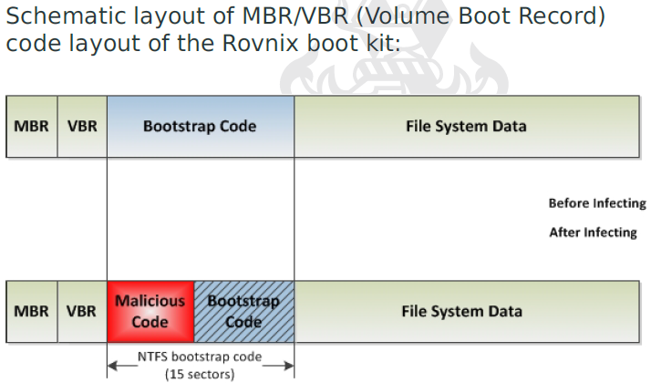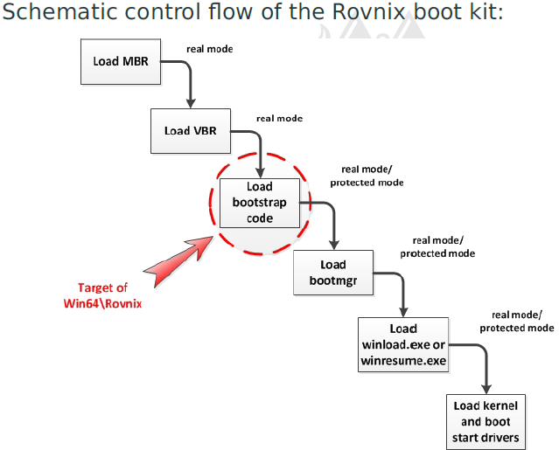

Chernobyl = zero-out flash bios (brick mainboard)

Mebromi = first BIOS rootkit (wild), after 07 POC (icelord)

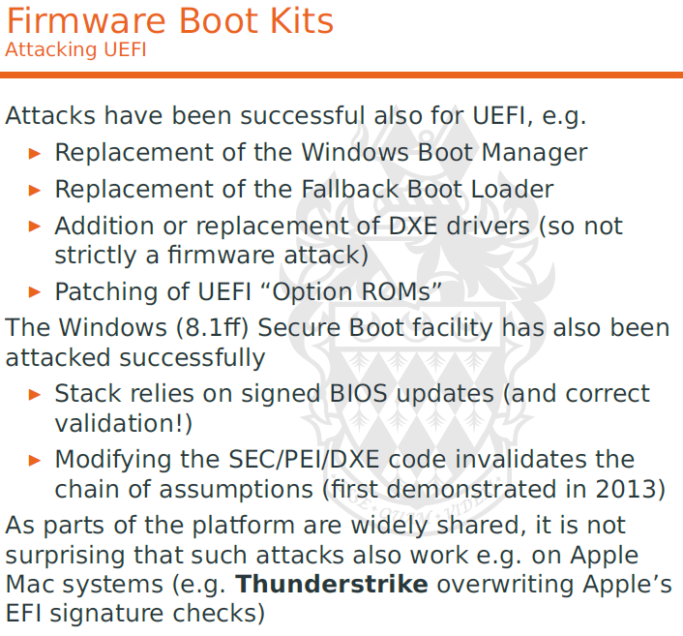Network Forensics

* Use of scientifically validated techniques to collect, fuse, identify, examine, correlate, analyze document digital evidence from multiple, actively processing and transmitting digital sources for purpose of uncovering facts related to the planned intent or measure success of unauthorized activities meant to disrupt, corrupt, and/or compromise system components, as well as providing info to assist in response to or recovery from these activities

Host-based Network Forensics sources

* Only data-in-flight
* Useful network info available only at endpt
* Obtain evidence from endpt / immediate nodes
* Trustworthiness questioned
  + Volatile , not logged/audited
  + Requires live forensics

Open Network Ports

* Netstat
* Establishing plausibility of connections (malware may be hidden)
* Use of tools = network queries (dns reso)
* TCP connection state = assist investigation
  + Port 80 to hide usually

More than network conn

* Network Routing Table
  + Not only IP, legacy/custom protocol
* Local firewall, connection filters
* Cached DNS resolution, LDAP, Netbios names

Host-based sources

* AV, IDS, IPS
* Reuse info at host level (other techq limited)

Network-component forensics info sources

* Obtained over network by active/passive
  + Valid info on hosts
* Scanning =
  + Availability of host
  + Finger printing of host OS
  + Not all service response to straight forward
  + Port knock req (reply to only some pattern)

OS Fingerprinting

* Can be masqueraded (make itself suspicious)

Application mapping

* Identification, including revision info
* Banner grabbing

NMAP

IPv4

* More info in fields of potential interest
  + Unusual combinations of fields (indicate malware presence)
* Hiding malicious stuff in the areas outside fragment offset (firewall check reconstructed, not everything)

TCP

* Source port = altered by Port Address Translation (PAT)

IP networking scanning technique

* SYN Scan (wait for SYNACK)
* TCP Connect Scan (perform regular connect)
* UDP Scanning (harder, as responses not always)
* STCP INIT Scan (equivalent of SYN scan)
* Flag Scan (tcp flag header)
* TCP Scans (only active connections)

Observing/sniffing network traffic (when host cannot be used for observations)

* Hosts cannot be assumed to be trustworthy
* Active network components (allow capturing of traffic, limited in volume)
  + Possible contamination

Network taps

* Port mirroring
* Needs to be configured
* Limited to 1 port usually (would be aggregated)

Host-based network traffic capture

* Wireshark

Protocol Analysis

* Obfuscate network traffic
  + Nesting protocol
* Requires protocol analysis
  + Manual RE, use wireshark
  + Must be fully captured

Capturing Wireless Traffic

* Directly from AP or upstream traffic
* Large network with same SSID (simplifies monitoring)
* Authentication (easy to spoof) EAP offers some link to auth data
  + Fingerprinting may offer further circumstantial evidence
  + Forensics (discovery of rogue/fake AP)

Capture Traffic unobtrusively

* Run in monitor mode
* Evil Twin attack

Issues

* Occur at different level of details
  + Header only
  + Selected packet length
  + Full
* Not with abs reliability/precision
* Specialised hardware, specialised constraints
* Data volume = problematic.

Network Flow Analysis

* Identification of compromised hosts
  + Proving/disproving info leakage, profiling
* Statistical aggregates
* Commonly used in incident response/anaylsis

Issues

* Synchronisation
  + Timestamp
  + Recording might be unreliable
* Integrity protected

Email Forensics

* Protocols = proprietary, or standardised external interfaces
  + Standard protocols = different versions/age
* Divided into **Transmission, storage, access**

SMTP

* Store and forward paradigm
* Email client (Mail user agent, MUA) transmit message to Mail Transport Agent (MTA)
  + Can contact more MTAs
  + Destination may not reach
* Set of header fields, mandatory/optional
  + Initiated by MUA, amended by MTA
* Final = Mail Delivery Agent (MDA)
* Simple TCP Model
* Spoof email = trivial as no validation for server/email address

SMTP header

* Min = From, Date
* Usually = To, CC, BCC, Subject, Sender
* Forensics Interest
  + Message ID (generated by MUA)
  + In-Reply-To (linking)
  + Received

Capturing Traffic and Submission

* Can be captured in flight
* Encrypted with SSL/TLS protocol
  + Can get dump from MTA, or warrant
* Designed to operate with chain of MTA
* Originally using port 25, now port 587 to Mail Submission Agent (MSA) with encryption

Email Transmission

* Submission = over proprietary protocol (MSExchangeRPC) or SMTP MSA
  + Actual = utilize SMTP when reach destination
* Locate host using DNS MX record
  + Priority = for main/backup server
  + Attempt limited re-transmission (delays)
* Protocol = send out to all with equal priority
* Inconsistent findings (when analysing traffic, taking different paths)
* Spam, virus filtering, load balancing, DNS round robin
* Depends on current config, network conditions, time of delivery, delivery failure/delays

Consistency Validation

* Even with SSL/TLS, not reliable evidence of transmission/receipt, irrespective of message
* Dig sig, encryption != conclusive where signing gateways are used.
* Email header can be forged, but consistently = hard

MDA protocol

* POP (simple, can use challenge response, Kerberos, SSL/TLS)
* IMAP (comprehensive, locally stored as cache)
* Proprietary = Exchange, Domino
  + Incomplete extraction of info, limited

Other MDA Mechanisms

* Web based access (Gmail)
  + Primitive = not leave trace
  + Enhanced = data on client system.
* ActiveSync (replicate to mobile phone)

Crypto Mechanisms

* Can help/hinder forensics investigation
  + Encrypted = require obtaining key/cached copies
  + Corporate = require backup/master key
  + End users= can delete recovery key
  + Can enable attribution, integrity validation
* Authentication, integrity protection != strong
  + Continuity of evidence for key = established
  + Attribution – dig sig = provide circumstantial evidence (not necessarily intent)
* Anti spam, like DKIM, plausible message traces of end-user encryption mechanisms

Investigating Email Traffic

* Must acertain integrity & authenticity
* Require recovery or large volumes of messages
* Public administration (sunshine law, freedom of info)
* Affects archival systems
* Data-mining techniques = use to identify keywords/concepts, correlation
* Not only 2 individuals (but network of individuals)
* Multiple email acc under same person, transliteration (non English names)

Obtaining Email Records

* Outlook = not good, limited ability
* Use Exchange management shell, 3rd party tools (F-response, encase enterprise)
* Backup copies, DB (best, with metadata)
* Message Tracking logs, paths, not message body (default 30 days, 1 GB)

Discovery

* Mutli Mailbox Search (search through mailboxes)
* Single item recovery (enabled by admin, 14 days)
* Litigation Hold, In Place Hold = legal requirement (or else contempt court)
  + Modified items tracked, allow tampering discovery
  + Tracked via “Auditing Mailbox Access”
  + Saved copy = Versions
* Cached Exchange mode (for offline mode)
* PST, OST = password protected
* Online mode = cached in memory, not OST

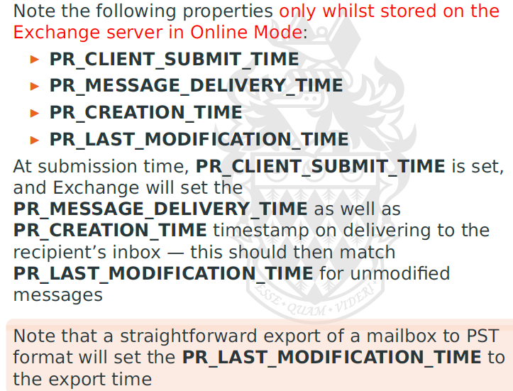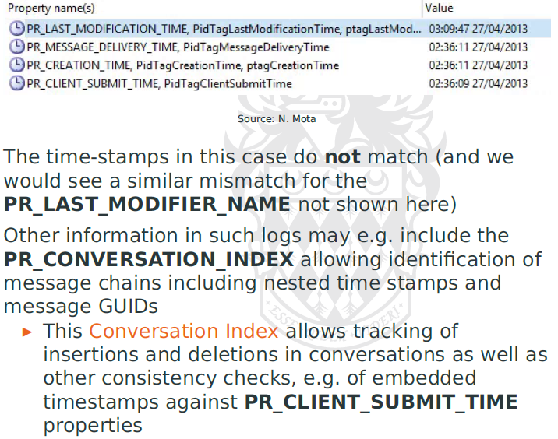

Stored locally (in EML files) for efficient reason

Unified Communications = built-in feature, (stored default in local cache)

Malware

* executed without consent of legitimate use
* violate system’s security policy

**Taxanomy**Viruses = insert itself into exec file, perform malicious funcWorms = replicate itselfTrojan Horses = covert func, malicious secondary funcTrapdoor = code permits priv access (if specific action)Logic Bomb = malicious code = triggered by external events (by dev, or ransomware)

**Autonomous propagation & Obfuscation technique**

* 75% malware infection = Trojan
* Adware & spyware = hard to classify
* Virus & Trojan = need human interaction (harder to describe propagation, share similar obsfucation)
* Trapdoors & Logic Bombs = payloads, tend to specialised (harder to summarise)

**Lots of java & flash,** browser disable it, now become browser/apps

Vectors = change rapidly

MacOS = rare, but…

* Malware = entered appstore
* New sign variants detected

Mobile malware = serious, sophiscated

* Detection rate = tripled
* Moneisation = more direct, secondary uses = limited
  + Stealing creds, personal info
  + Depends on country market penetration
* Does not need to propagate, but remove itself (hard for recovery of evidence)

Computer Viruses

Propagation techniques

* Boot sector (init code substituted) *forget to take out disk when restart, install itself
  + Obsolete once new OS (MBR > GPT)
* Executable infection (insert in exec code)

Basic injection strategies

* Naïve approach (sub/prefix exec code)
  + Block using signature
* Evade detection = polymorph, self-encrypt, multi-segment
* Increased effectiveness = shared objects (DLL)

Virtual env (like browser, mobile) = blur

* Can execute within runtime, access to OS may not be needed (to steal stuff)
* Evidence = found at different level

Macro(script) Viruses

* Apps have Embedded programming facilities (office products, flash)
* Suitable env for virus authors (expose underlying OS)
  + Can assemble, compile just in time, cant be seen
* Dominant threat, (easy to send docs)
  + Embedded script = lack of better term

Malware Detection

* Signature matching = identify known/minor variations
* Deciding program infected = undecidable

Prevention/Mitigation = Use of restrictive security model, limit to trusted program = reduce risks

Adv malware detection

* Ongoing research = characterise virus (positive/negative)
  + Use behaviour anomaly
  + Analyse control flow of app
  + Control flow fingerprint
  + Bad behaviour = changed control flow pattern
* Heuristic = have false positive
  + Response = realtime, reaction to FP = disruptive
* Realtime constraints = forensics, interactive approach cannot use
* Effectiveness =dubious

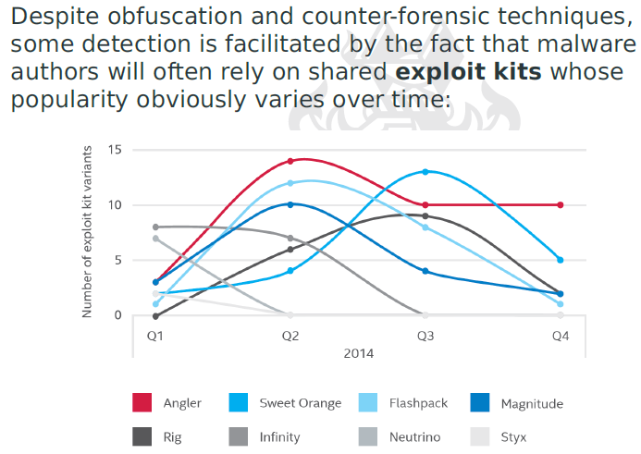

Ransomware As a Service = available to public

Forensic analysis of malware

* Specialised task by AV researchers/vendors
* Called upon, when malware COULD have performed a certain action

Infiltration mechanism

* Malware = targeted at particular hosts/service/victim
  + Intel info = direct infiltration
* May have social engineering component
* Small = Selective FP, & investigation = feasible
* Or else = scanning required

Passive network-based infiltration

* Trusted/partial = straightforward
  + Propagation over shared drive
  + Email/messaging (file transfer, active content)
    - Has SSL/TLS, hard to detect
* Comm channels = include other networks
  + Via 3G/wifi/BT, continue via sync/file transfer

Document Malware

* Macro code
  + MS office, Open office
  + Adobe PS, PDFs
* Office = easy, PDF (assumed safe)
  + Hyperlink = drive-by downloads
  + PDFs = scripting, include JS
  + Native support = encryption/encoding = polymorphous/metamorphous malware (easy)
  + Adobe = sandbox (bypass sold for 50k USD)
  + CVE2013-0640 = mem corruption, code exec
* Font type management (15 vulns)

Drive-by Download

* Web browser vuln = exploited
* payload further download actual malware
* XSS attack, steal data
* Trigger-able by different features  
  Sharing “indirect user action” = pre-req
  + HTTP/HTML/JS
  + Using HTTP as transport & tunnelling protocol

Caching, performance = download beforehand  
(lots of traffic = cat videos)  
- harmful?

* File transfer = local handling with codec installed
* Streaming content (HTML5 tags)
* Each container/codec permutation = may hav vuln
* Not possible to filter all vulns
* May upload contain with exploit code (induce user to process data)

Video – exploit CVE2014-0515

* Flash video, cross platform
* Heapspray
* Buffer overflow = overwrite indices in table methods
* Second stage = search for lib loaded in memory
* Multi=stage malware
* Appears on Syrian gov site from 2011

Maladvertising = embed links, malware in advertising

No strong mutual auth = MITM

* Spyware, adware
* Bad Root CA installed

MOTS = Man on the side

* Read traffic, insert traffic (rely on timing adv)
* Law enforcement, with lawful interception

Active Network based infiltration

* Probe small set of vuln
* (minimize likelihood of detection)
* No feedback possible, probing=blind, attempt to deploy payload
* Infiltration = rapid/automated interactive

Worm propagation strats

* Scanning
  + Stages
  + Exploit, priv esc, remote
  + Intel collection, propapagtion
  + Probes/exploits new target
  + Replicate on target
* Coordinated scan
* Flash
* Meta-server
* Topological
* Contagion

Slammer = fast worm, no feedback,

* Exploited MS SQL, resolved in 2002, population in less than 10 min

Worm = share similar with biological epidemic

Simple SI model

* Susceptible indiv, and infected indiv
* Infection rate B, population size N
* Distribution = 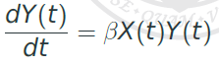

Kermack-McKendrick Model = rapid rise & fall of infected patients

* Has new group = Removed indv (immunity)
* SIR model
* Removal rate = p
* Large p = pandemic occur
* Simple = not accurate for computer worm

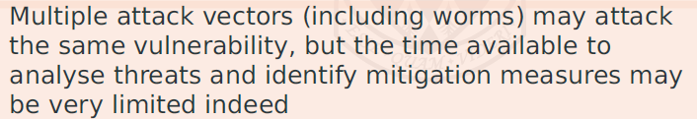

Scanning strategies

* Random scanning
* Subnet scanning
* Hitlist
* Topological scanning (network/layered, in p2p, email)
* Routing worm (uses BGP)

Key objective = rapid initial propagation = makes vaccination (patching) ineffective = pandemic

Detection of scanning worms

* Must aim to identify indicators of possible worm traffic
* Deploy probes in different location = detect signature
  + Network telescopes
  + 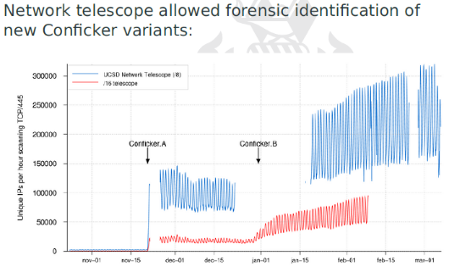
  + If not randomized = comprehensive probing = needed
* Data = nosiy (multiple, legit traffic concurrent)
* Malware = can be stealthy
* Analysis = form of pattern identification
* Requires reliable baseline dataset (but always change, lack of info on usage)

Forensics = more than anomalies, prove cause & effect

Pattern recognition

* Reduction of dimensionality
* Normalisation of data = eliminate noise
* Wide range of pattern recognition/classification

Automated signature inference

* Simple, trivial attack
* Correlation of traffic = identify crucial patterns

Kalman filter = filter noisy signal

Detect worms/malware = distributed sensors

Params = scan rate, distribution, num of identified scan, num of known infected hosts

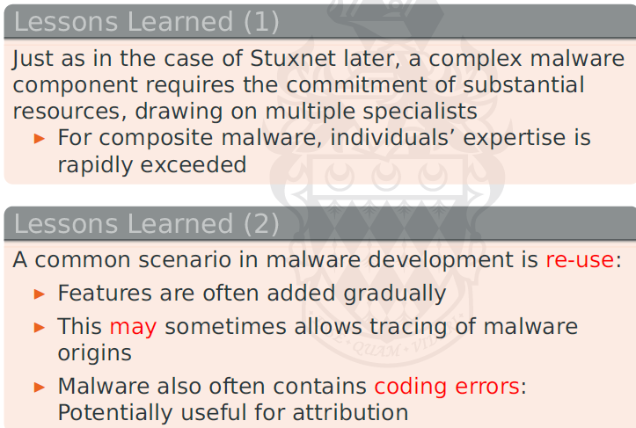

Evading Forensics Analysis

* Check for forensics tools, sandbox env
* Malware authors = protect IP, prevent RE
* Some obfuscation = detection EASIER
* Rombertik = self destruct, erases, overwrite MBR, encrypt files with random RC4 key

Common technique

* Random long sleep
* Rombertik = write random data, flood logs, stalling tracing tools
* Check for hooks
* Static/dynamic = confusing

Exfiltration mechanisms

* C&C to take personal data
* Industrial espionage = take doc, report activity

Backdoor Mechanisms

* Via TCP = too conspicuous
* Have NAT/PAT, or have firewall

Port knocking

* Seq of connection attempt, before accepted

Reverse Backdoor

* Use intermediate nodes, minimise traceability

Covert channel

* Comm pathways = cannot be blocked entirely
* 2 classes: storage channel, timing channel
* Capacity = not only limited by bandwidth, but error handling, correction
* Noiseless = only 2 parties
* Noisy = used by other ppl also
* High assurance systems = retain num of covert channels
* Other than elimination of shared resources, mitigation = required
  + Perfect isolation
  + Unworkable in most env
* Can reduce bandwidth, resources avail uniformly

Covert channel endpoints

* Establish = hard for adversaries
* Needs to learn compromised hosts
* Prevent traceback to C&C
* Centralised, hierarchal topo may not scale

Fast Flux

* Gives u different IP every time

Single flux (based on DNS A records)

Name server Flux (also change NS records)

Double flux = combination single and NS flux

Legit = like Cloudfare, Akamai

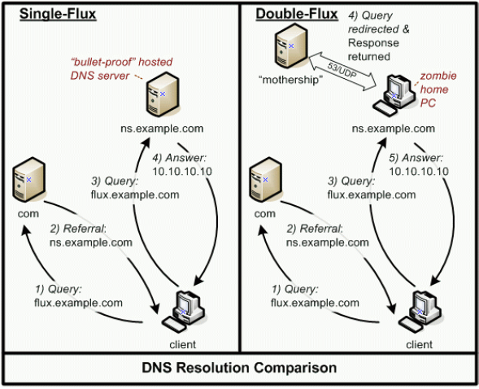

Detection and concealment

Detection of Malware = impossible to construct perfect malware detector

Binary mod strat = malware that require persistent exe file, dyn mod of process

* Substitution
* Pre-pending
* Appending
* Cavity (inject code in arbitrary location)
* Multi-cavity (split and above)
* Use slack space in executable (firmware, interpreted data = potential targets)

Packers = masquerade exec, minimize payload

* Has decompression engine
* Compression + encryption
* Packer =polymorphism
* Anti-debugging/anti-forensics = obfuscate code structure, observability, VM presence detection

Rootkits

* Apply concealment mech
* Prevent detection in compromise stage

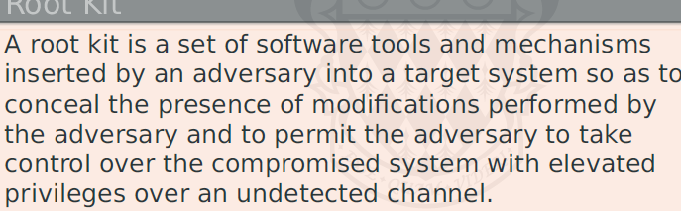

Binary/Userland rootkit = first/least sophistacted

* Sub/mod binary executable to avoid detection by tools
* Requires knowledge of all tools
* Size = issue = toolsets more comprehensive
* Integrity checks = evaded
* Remote code injection (DLL injection)
* Overwriting/hooking call table
* Known good behaviour, file signature = identified online/forensically
  + Requires live technique
  + Rootkits = target detection subsys

Kernel rootkits

* Mod of kernel using direct hooking or DKOM to loadable kernel modules
  + Can occur at multiple location (not just obvious syscall, or driver interfaces) – too easy to detect in integrity checks
  + Anaylsis of kernel data struct for anomalies.

Persistent rootkit (Survive reboot)

* Registry key
* Startup
* Non-existing safedllsearchmode
* Addons to existing app
* Ondisk binary patching of bootloader, kernel, device driver
* Mod of boot records
* Firmware mod

Malware anaylsis techniques

* Code = matched against known signatures
* Most malware = some form of obfuscation
* Static/dynamic analysis method required for RE, and understand actions

Static analysis

* Requires understanding of dependencies, library, services
* Form of disassem needed
  + Requires recursive analysis (control flow)
  + Can counter
* Pop tools = IDAPRO, hopper, Radare2

Dynamic analysis

* Observing code in runtime
* Malware = employ cloaking, obfuscation, monitoring observation mechanisms
* Dynamic analysis = must appear close to real, vulnerable system (or may use different code paths)
* Malware = seek to detect modified env with instrumentation for analysis

Mobile Device forensics

* 80% investigation = involves mobile
* Mobile = mobility, link to cellular network infra
* Tablets, watches, vehicular sys

Tracking = beyond scope of lecture

Majority of devices = GSM/3G/4G/5G, IDEN, = uses SIM modules

Investigation Pathways

* Manual examination & screen capture
* Needs device to be unlocked
* Surprising Low tech, more likely to preserve integrity = initial choice
* Logical analysis & data struct = requires access

Strong encryption = physical, chip off analysis decreasing

Baseline info

* Device info, call & text registers
* IMEI, SIM identification
* Recently dialled & received, missed calls  
  time, date,duration
* Phone book contacts
* SMS, MMS messages
* Calendar info, service book info (roaming)

Data = correlated, corroborated by network operator data, and platform (google)

* A lot more other info (email, web, notes)

Memory location

* USIM
* Onboard memory
* Memory card
* SRAM

Fingerprint sensor (forensics usage)

* Biometric template data = stored in secure enclave
* Calculations on sensor data, templates = outside of enclave = may recover sensor data capture

Basic phone examination

* SIM PIN can be reset using PUK
  + Biometrics can replace pin, but not after cold boot
* Data stored on device and memory = retrieved without tools
* Benign cases = commercial tools exists

Challenge = phone locked, obfuscated data

Simple = use smudges

Pin codes

* Simple =can brute force (using external device)
* Device normally rate limit entry
* Can cut power after failed attempt
* Brute force pin = 100 hours, fully automated

SIM – cloning may be required, may need trusted module in handset

* Changes to evidence (remote wipe = risk)
* Insulate handset from network (avoid risk)
* Cloning = reduce data loss (locked sim, not all data can be read/recovered)

Jailbreaks (attack vuln in OS)

Low level access:

* JTAG (Joint Test Action Group)
* Test Access Ports (TAPs)
* Debug interfaces   
  (supports breakpoint, single step)
  + In-circuit emulator
* Proprietary, available under NDA
  + Subsidised handsets

Direct Memory Access (chip off techniques)

* Physical memory access to flash
* Flash mem = highly robust
* Need to heat up

Physical Circuit Access

* Memory = self erase (OS param exceeded, tampering detected)
* Bus line = encrypted
* Hardened against fault injection, timing, power analysis (side channel attacks)
* Physical employed = stakes are high
* Uses microscopes, probe stations

Physical circuit manipulation

* Use ion beam / laser cutters, to manipulate circuit

Flasher box = Undocumented maintenance mode codes access devices (clean IMEI for unlocking)

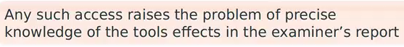

Simple Counter-F

* Stolen/disposable phone
* Prepaid sim

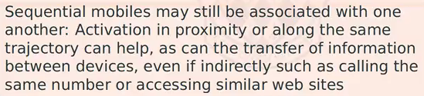

**Android Forensics Fundamental**

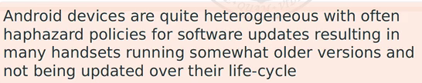

Software = Open Source (expt proprietary extensions)

* Store = rich source for forensics analysis
* Manufacturers = have proprietary apps / cloud
* Hardware = variable (RF, USB, sensors, GPS, cameras, microphones)

Most uses internal flash memory

Own flash translation layer = memory architecture

* Flash and SDRAM

Boot = manufacturer ROM, boot loader, linux kernel, Zygote (forks everything) and Dalvik env (sandbox)

* Validate against dev signature

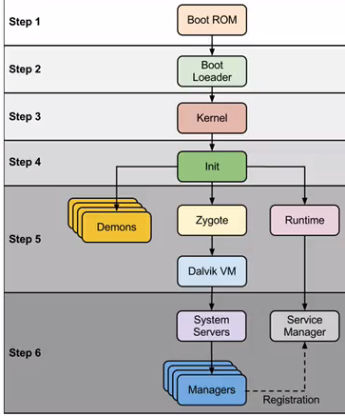

Has free AVD

Dalvik -> ART (runtime env)

* Uses JIT (just in time ) compilation
* ART = ahead of time compilation

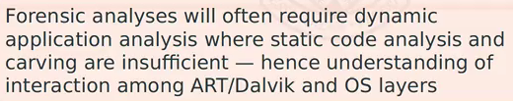

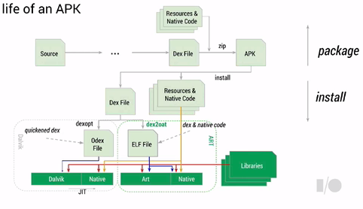

Devices = more secure, variety of platforms

* Integrity can risk = use bootloader mode
* use RF firmware
* Use Goldcard (bypass carrier id check when flashing ROM)
* White card (sim card for diagnostic mode)
* Combination of tools allow special mode S-OFF, custom boot image
* Forensics image can stop boot chain, avoid writing flash

Android storage access

* Block storage
* FTL Flash translation layer

Different storage = different drivers, different file sys = different techniques = different level of access (unlocked, debug, root)

Partition Layout

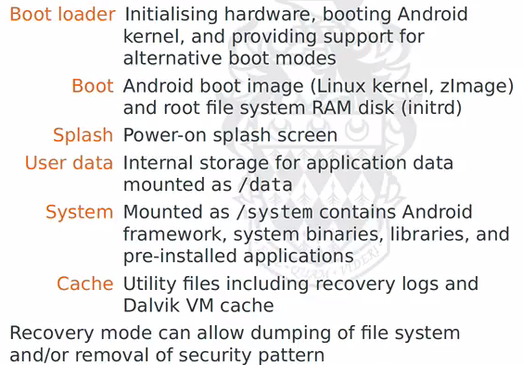

Storage (intact)

* App data in different location
* Shared pref = simple key-value pair in XML
* Stored on per-app basis (require root access)
* External storage (mem cards)
* SQLite DB
* Network

Useful

* Browser
* Call logs
* Contacts
* Mediastore (media files)

Some network caching data recoverable (dropbox)

YAFFS2 = Log structured file system (for NAND flash)

* Header and data chunks
* Mapping kept in RAM with checkpoints saving state
* Clears obsolete chunks via GarbargeC
* Does wear-leveling (rare)

Android Storage Encryption

* 128 AES CBC, master key (password-derived & salt)
* Key Encryption Key, KEK = stored in trusted execution environment (limit offline attacks)
* Password = limiting factor v

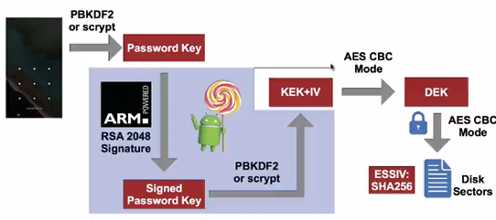

Android App Analysis (static/dynamic)

* Auto check for malicious behaviour (bouncer)
* Detect interesting behaviour (kernel logging)
* White list ot feasible

Google play = open, significant num of malicious/borderline apps

Independent app stores = higher proportion of mal app, less well policied

Active families of mal app vary over time and location



Interesting:

* app data (IM, apps)
* BYOD (tracking facilities)
* Log files, pic, pref
* WA messages, files, data, geolocation
* Storage locations (inside DB & file stores)
* Deleted = (interest), FS/logs can track deletion

WA – messages = indirect via central servers (allow async message forwarding)

* Media data not exchanged directly (URI with SHA256 keys)
* Different states
* 1-1 easy, group chat = harder

GMaps

* GPS (using AP, mobile phone tower)
* Has location cache files (info limited)

Android Memory Access

* Uses ADB (need USB debug interface)
* Nandroid = need root
* Commercial tools = got cert/accreditation

Acquiring reliable memory image

* Layering btwn host + app space
* Separate analysis of respective VM
* Memory layout of data struct (hard)
  + Interpreted/compiled code

iOS

* 8 = really hard (addition of secure element)
* User data = protected via strong encryption
* Earlier = hardware-key, lib & cache not encrypted

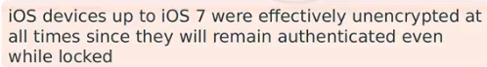

iCloud

* Some law requires mutual assistance request

Pairing (iOS7, device access possible)

* Juice Jacking (will ask user to authenticate device)
* Services = allow File Relay  
  Unhindered access to all data (plaintext)
* No longer after iOS 8
* Pairing record (can use to access some data)

Encrypted backups (no rate limit on bruteforce)

Apple Configurator (access via Escrow keybags)

iOS 8 = secure boot chaining ( online validation, JB = hard)

* Secure enclave A7-A10 processors
* Device-specific AES key inside
* Derived key = PRNG
* Explicit mechanism to ow flash location of key

iOS 8 = encrypt all data partition files (key = derived from hardware + passcode)

* No Protection (encrypted only with UID key, unprotected once device is on)
* Protected until first user authentication (default)
* Complete protection (plain text retained 10s after locking)
* Protected unless open (app left open while device locked, data key in plaintext)

Keychain items = only secured until first unlock

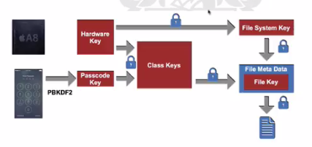

Keychain = contains crypto info